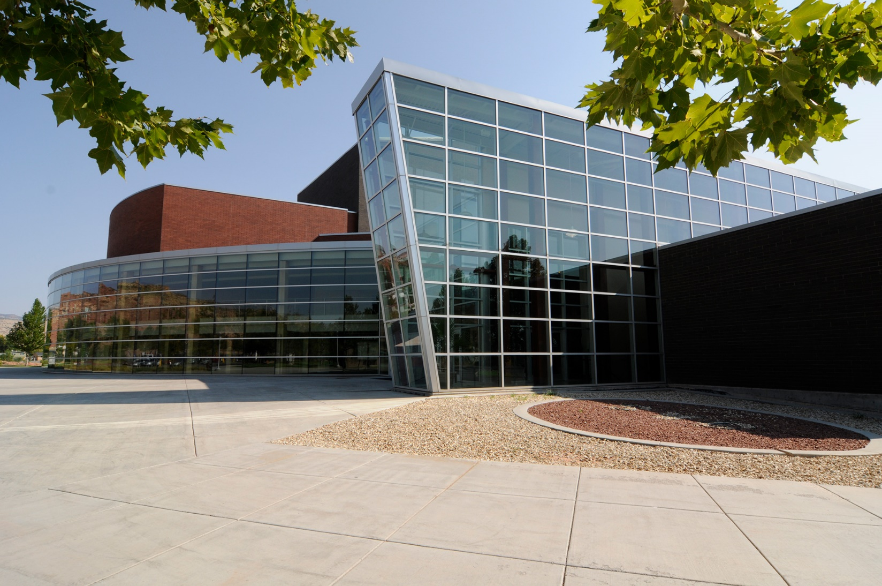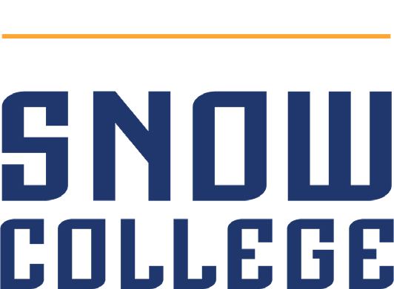

OPEN POSITION:

Groundskeeping Lead

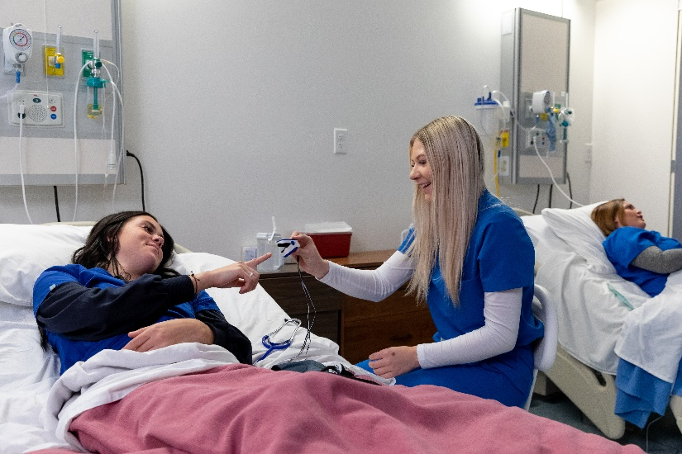
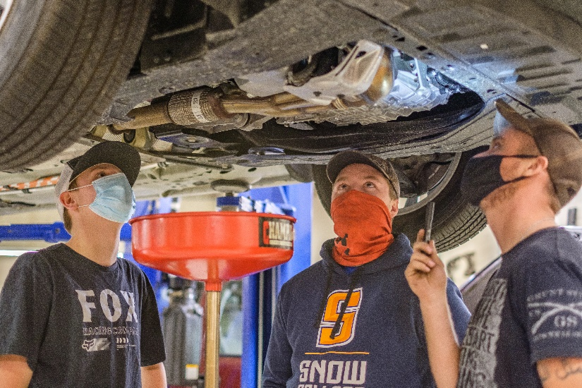
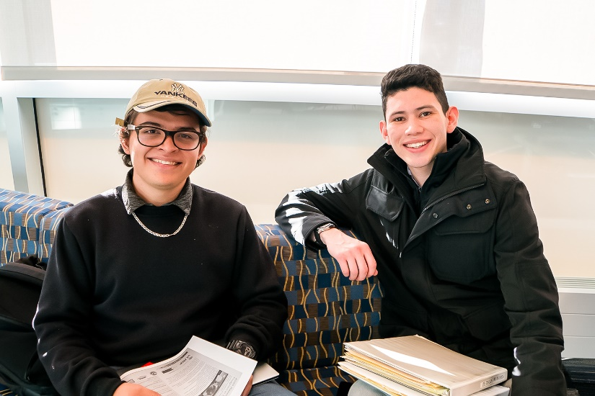


About Our College
Snow College is a two-year public college. In January of 2020 The Chronicle of Higher Education ranked Snow College #1 in the nation for student success of two-year colleges. Located in the heart of Utah, at the foot of the Wasatch Mountains, Snow College is the oldest comprehensive two-year college in the Western United States.

The College was established in 1888 and excellence continues to be the hallmark of our work and activities. We are the preferred choice of approximately 6,000 students who want a small college experience filled with a variety of activities, events and performances, to go along with their outstanding academic opportunity.

Snow College offers programs and courses which are highly interactive and are designed to reach a broad spectrum of students: high school students desiring college courses, traditional on-campus students, technical edu cation students, online students, and non-traditional students who wish to start or complete a degree. With campuses located in Ephraim, Richfield, and online, students are able to complete degrees in Associate of Arts, Science or Applied Science or have the option of numerous specialized, short-term technical training certificates and diplomas including a few programs with bachelor’s degrees. Snow is committed to the success and positive experience of every one of these students.

Highlights
- Snow College won 2021 Best of State Awards in the following areas: Higher Education Administrator, College/University Teacher, Educational Advisor, Curriculum Development, and the Best of State Statue award in Education.
- Small class sizes result in students receiving more personal attention and specialized assistance from
dedicated professors and advisors.
- Low tuition, housing and fees make Snow College the most affordable and best valued college in Utah.

Mission
Snow College continues a tradition of excellence, encourages a culture of innovation, and cultivates an atmosphere of engagement to advance students in the achievement of their educational goals.

Roles of Snow College
Building upon a tradition and heritage of academic distinction and personalized attention, Snow College fills the following roles:
- Snow College serves as one of the nation’s finest two-year transfer institutions with a focus on liberal arts and sciences, and maintains cooperative relationships with distinguished colleges and universities.
- Snow College enhances the economic development of Central Utah through partnering with business, industry, government, and community to provide high-demand professional, career, and applied technology education.
- Snow College enriches the educational, cultural, and recreational life of Central Utah through community and continuing education opportunities, cultural and athletic events, and community outreach services.
- Snow College is dedicated to helping individual students achieve their academic goals through a caring, personalized learning environment, providing comprehensive student success services, library and learning resources, and targeted supplemental and developmental education programs.
- Snow College focuses on developing the whole student and encourages student involvement in a wide variety of co-curricular activities, service organizations, service learning opportunities, academic and special interest clubs, athletics, and student leadership opportunities.
- Snow College welcomes all who will gain from or contribute to its educational and student-centered environment including individuals with diverse backgrounds and perspectives.
- Snow College partners with higher education institutions which offer baccalaureate and graduate programs in select disciplines for the citizens of Central Utah.

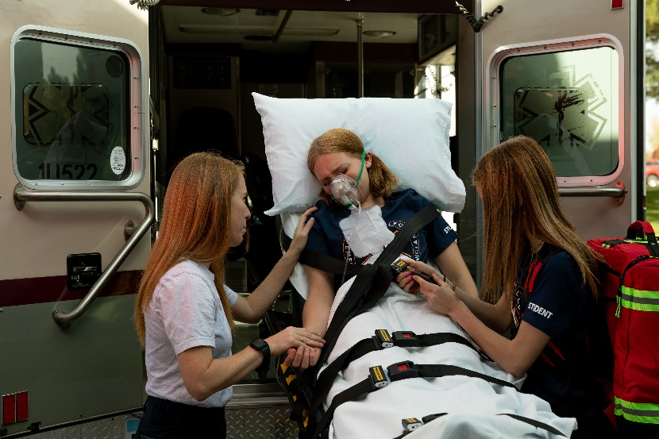

The Job
Description:
The purpose of this position is to maintain the ground so that it has a pleasing appeal to the community and to students/prospective students. The grounds have to maintain in a way that there are not any safety issues that can cause a risk to the public. First Impressions. When people come to visit the College the first thing they see is the grounds and first impressions mean a lot. To a visitor, if the grounds are not maintained it can have an adverse effect on the school.

Qualifications:
- 3-5 years of ground related experience, required;
- Must be able to supervise student, employees, part-time employees;
- Must be able to supervise and oversee service hour individuals;
- Must be able to plan and oversee service projects;
- Must have the ability to read and write basic English;
- Must have the ability to follow simple oral and written instructions;
- Must be able to lift 50 pounds easily, lift and move heavy equipment and furnishing, be able to climb ladders and work from heights of 20 ft. or more;
- Willing to establish and maintain working relations with supervisors, fellow workers, and students (public relations);
- Must be self-motivated;
- Must be able to follow instructions;
- Must pass a criminal background check.

Duties:
- Outlines daily tasks for all grounds needs and assigning tasks for employees and inmates
- Oversee and arrange the following training:
  - Safety, OSHA regulations
  - Licensing for herbicides and pesticides usage
  - Backflow certification helpful
  - Turf management
  - Arborist training helpful
  - Aerial lift training
- Accurate record-keeping of leave time for part-time staff
- Accurate record-keeping of equipment locations, where, when it was purchased and cost
- Schedules and keep a record on O/M maintenance on equipment
- Works with purchasing
- Keeps a record of inventory on hand
- Works with Richfield City with water and ballfield needs
- Order fuel for grounds as needed
- Oversees the design of sprinkler systems and landscape projects and asphalt and sidewalk needs
- Designed floral arrangement for college planting beds
- Coordinates and oversees park and concrete projects
- Oversee maintenance of trees and shrubs
- Utah driver’s license required
- Other duties as assigned.
Diversity & Inclusion
The Snow College administration, faculty, staff, and students, affirm our commitment to diversity and inclusion, and consider them essential elements of a vibrant learning community and integral to our institutional mission. We are determined to foster an environment of inclusion, diversity, openness, and respect for the many differences that will enrich the Snow College community, including race, ethnicity, religion, gender, age, socioeconomic status, national origin, language, sexual orientation, and disability.

Snow College:
- Encourages and welcomes respectful dialogue and exploration of diverse ideas, topics, perspectives, and issues to enrich our campus community.
- Promotes equitable access to all in academics, leadership opportunities, and employment.
- Enhances opportunities by encouraging all to share their cultural experiences and identities, allowing others to learn from this exchange.
- Invites applicants and employees from all backgrounds to foster respect, understanding, awareness, pluralism, and cooperation in an increasingly complex, diverse, global society.

Strategic Plan
This position is an important part of the College’s Strategic Plan.

Living & Working in Sevier County
Sevier County: countless hiking and ATV trails, Fishlake National Forest, an hour away from Capitol Reef National Park, Eyes to the Sky Balloon Festival, concerts and other events at the Sevier Valley Center, rodeo and equestrian events, Fremont Indian State Park, and more on the Sevier County Website.

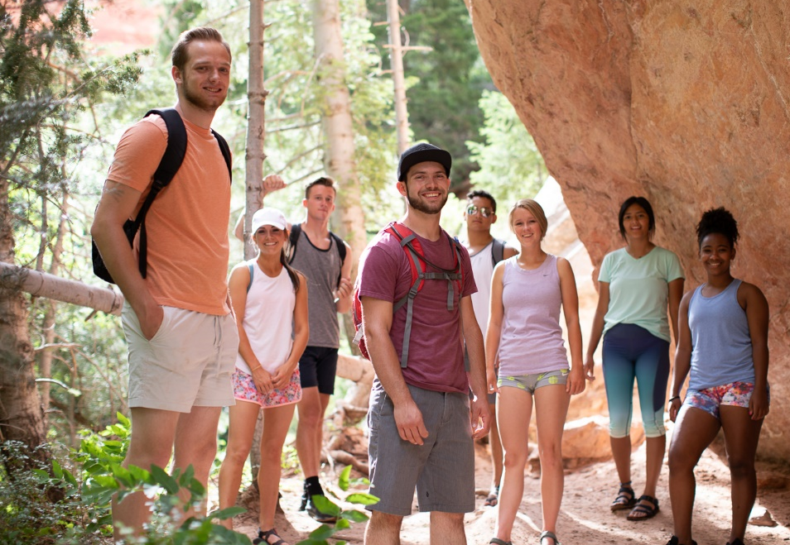

THANK
YOU!

Thank you for your interest is Snow College!
Please apply at https://www.schooljobs.com/careers/snowcollege.

This position will remain open until filled.

If you have any questions regarding this position, please contact the HR Recruiting Specialist at
jobs@snow.edu or hr@snow.edu.

