Assessment Day Annual Program Review Template ^{1.B.1, 1.C.5}
Please update the fields in the table below.
Program:
Division:
Primary Contact Name:
Primary Contact Email:
Contributing Faculty/Staff/Administration
Program Overview
Program Description (please make sure this matches what is listed on your program website and your section in the Snow College Catalog.)

Degrees and Certificates Offered (list in order)

Does the program have an established Advisory Committee?
Advisory Committee Member Name | Committee Affiliation

Identify up to three exemplary programs and describe what makes the program distinct from other peer programs.
Peer Institution and Program Name | Exemplary Differences

STUDENT PROFILE ^{1.D.2, 1.D.3, 1.D.4}
Use the Annual Program Review Dashboard to complete the Student Profile Table
- Go to the Start Here Tab—here you will find a glossary of terms and the source material for the dashboard.
- Go the Academic Demographics Tab (tabs are the top of the dashboard)
  - Under the “Academic Year” make sure the 2019 Academic Year is selected. This represents the most complete fall and spring term (spring 2020 term is not yet complete).
  - Under the “Division” select the Division that houses your program.
  - Under the “Subject”, check the box(es) that represents your program. Please note programs are largely determined by subject prefix and more than one box may need to be select to capture appropriate data.
  - Write down the total number of students: ______________________
(this is in the total enrollment box)

- Using the same Academic Demographics Tab identify and record the demographic details in the table below.
Student Profile Table
Demographics | Institution  (first column) | Division  (middle column) | Program  (third column)
Total enrollment
Percent or Count Female
Percent or Count First Generation
Percent or County Minority
Percent or Count Non-Traditional
Percent or Count Pell (low income)

The Academics Demographic Tab (2) provides the same program information disaggregated by semester and specific achievement equity gap category (i.e. gender represents male and female students). It is provided as an additional resource.
- Examine and describe the differences and similarities between student profile trends at the institution, division, and program levels.

COURSE ANALYSIS
The goal this section is to identify and enhance courses where there is the greatest potential to improve student learning and success. This section provides quantified measures at the course level that are related to course and program learning outcomes.
What courses should we evaluate?
- If your program has collected outcomes assessment data
  - Use these courses (not all courses should be evaluated)
- If your program has not collected outcomes assessment data
  - Examine a gateway course within your program
It is important to select courses that speak to your program’s student learning and overall program learning outcomes. Some courses may address more than one learning outcomes.
What course(s) are you evaluating? (add rows as needed)
Course Subject/Number | Course Title | Semester(s) Taught

Section 1: Successful Course Completion ^{1.C.7, 1.D.3, 1.D.4}
Examine successful course completion of your selected course(s) and consider student demographics and performance trends in relation to your division’s overall successful course completion trends. You are responsible for providing division data and course specific data.
Use the Course Completion Rates Tab to generate a Tableau graph that shows successful course completion for the institution, the division, and the program.
Follow these steps:
- The first chart represents Institutional Course Completion Rates
- Make sure the second chart is on the division that represents your program (see the blue Division filter).
- Make sure the third chart is on the subject(s) that represents your program (see the blue filter above the chart).
- The fourth chart uses the filters on the right to disaggregate program course completion rates by achievement gap groups.
- Click on the box with the downward arrow (on the bottom menu bar)
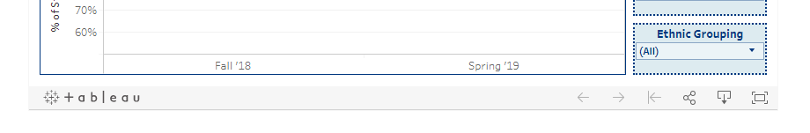
- Select the PowerPoint option from the pop-up menu.
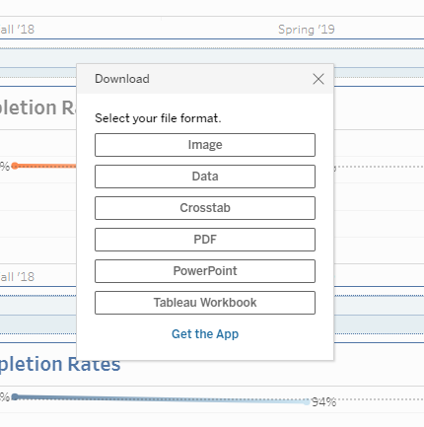
A PowerPoint slide of the data will be downloaded. You can use the copy/paste function in PowerPoint to copy and paste the image to this document.

[Paste the image here]

- Examine and describe the differences and similarities between the institution’s, and division’s overall successful course completion trends and your program data trends.
 | Fall Semester | Spring Semester
Institution
Division
Course
Difference

- Examine and describe differences and similarities between your program’s overall successful course completion trends and the disaggregated data trends for difference achievement gap groups.
 | Fall Semester | Spring Semester | Overall
Division
Program
Achievement Group?
Achievement Group?
Achievement Group?
Achievement Group?

Section 2: Course Enrollment & Grade Distribution ^{1.C.5, 1.D.2}
This section considers a deeper examination of student performance using average numeric grades per course. For this section, you will be comparing course enrollment and grade distribution trends for your course(s) with overall division data trends.
Go to the Academic Gaps Tab and follow these steps. You may also use the GPA Trends tab to make this analysis.
- Make sure the Division, Subject, represents your division and program. Also make sure the Academic Year is 2019.
- Using the same steps as before, generate a PowerPoint image of the data and copy and paste it into this document here.

- Examine and describe the differences and similarities between your program’s overall average GPA with GPA trends for key program assessment or gateway courses (see course selection on page 3.

- Address any achievement gap differences between your program and trends found for specific courses based on student demographics of gender, ethnicity, first-generation status, financial need, geography or other.

- Describe any recommendations you to address weaknesses in student achievement.

Go to the DFWI Rates Tab and follow these steps. You may also use the DFWI Trends tab to make this analysis.
- Make sure the Division, Subject, represents your division and program. Also make sure the Academic Year is 2019.
- Using the same steps as before, generate a PowerPoint image of the data and copy and paste it into this document here.

- Examine and describe the differences and similarities between your program’s DFWI rate and the DFWI rates for your division and the institution. You may reference courses in your analysis.

- Address any achievement gap differences between your program’ DFWI and trends found for specific courses based on student demographics of gender, ethnicity, first-generation status, financial need, geography or other.

- Describe any recommendations you to address weaknesses in student achievement.

PROGRAM OUTCOME ASSESSMENT ^{1.C.5, 1.C.6, 1.C.7,}
The goal of this section is to identify and enhance student achievement of program learning outcomes. You may use the same course(s) or additional/other course(s) that those selected for the course assessment section (see page 3).
List your Program Learning Outcomes and the applicable key elements or metrics established to assess student achievement.
- Program Learning Outcome 1
  - Key Performance Metric 1
  - Key Performance Metric 2
- Program Learning Outcome 2
  - Key Performance Metric 1
  - Key Performance Metric 2
  - Key Performance Metric 3
Complete the following table using data from your outcomes and performance metrics.
Program Outcome | Course | Assignment Title | Total Assessed | Number of students with achievement | Number of students with insufficient achievement | Benchmark | Overall student Attainment (based on benchmark)

- Based on your program outcome assessment data, briefly describe the strengths and weaknesses in student achievement for each program outcome.
Outcome 1:

Outcome 2:

- Describe any recommendations to address weaknesses in student achievement of program outcomes.

Outcome 1:

Outcome 2:

- Attach a copy of any assignments (with instructions) and examples of any student work that demonstrates achievement and insufficient achievement.

REFLECTION ^{1.B.2, 1.C.5, 1.C.7}
Reflect on the data you have examined in the Program Profile, Student Profile, Course Analysis, and Program Assessment.

- List 1-3 data observations or trends that you discovered in your assessment of student success in the program.

- List 1-3 data observations or trends that your discovered in your assessment to needed student improvement in the program.

PROGRAM GOALS and RESOURCE NEEDS ^{1.C.5, 1.C.7}
This section of the program assessment uses the results of the assessment to inform planning that supports student learning and success. Program members are asked to identify and monitor goals that result from the assessment of student learning in the tables provided below. These will be reviewed and updated annual to reflect progress made.
Goals
As part of our work on continuous improvement, this section identifies program goals that will support student learning and success. Each goal should be something the program needs or wants to accomplish in support of the program’s vision. Program goals should consist of actions that can be completed by program members.
Goal:
Rationale:
Resources Needed:
Goal Manager(s):
Projected Date of Completion:
Goal Progress/Update:

Goal:
Rationale:
Resources Needed:
Goal Manager(s):
Projected Date of Completion:
Goal Progress/Update:

Goal:
Rationale:
Resources Needed:
Goal Manager(s):
Projected Date of Completion:
Goal Progress/Update:

Goal:
Rationale:
Resources Needed:
Goal Manager(s):
Projected Date of Completion:
Goal Progress/Update:

The annual program assessment must be completed and submitted to the Office of Academic Affairs by June 1. Any attachments must be included in the report. To submit the document, access and upload your document and other applicable materials (student artifacts, rubrics, etc. to your program’s folder on the Assessment Day Teams site. This folder is found under the main Document Library tab/link and under your Division’s link.

Feedback reports for each program assessment will be provided by the Office of Academic Affairs by August 1 in preparation for fall assemblies and faculty planning meetings. Feedback reports will be uploaded to the same program folder on the Assessment Day Teams site and/or emailed back to department/program chairs.

