Chapter N

Variable: letters or other symbols that represent unknown numbers or values

The Identity Property of Addition a + 0 = a
The sum of any number and zero is the original number. For example 5 + 0 = 5.
The Identity Property of Multiplication a x 1 = a
The product of any number and one is that number. For example 5 * 1 = 5.
The Inverse Property of Addition a + (-a) = 0
If you add a number and its opposite it equals zero. For example, the additive inverse of 12 is –12.
The Inverse Property of Multiplication a x $\frac{1}{a}$ = 1
The product of a number and its reciprocal is 1
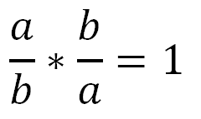 or 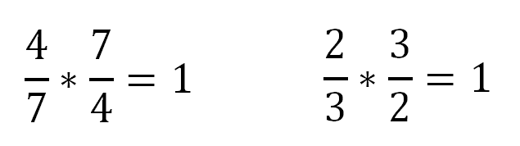
To get the reciprocal of a fraction, just turn it upside down. Example: the reciprocal of $\frac{3}{4} is \frac{4}{3}$
The Commutative Property of Addition: a + b = b + a
When two numbers are added, the sum is the same regardless of the order of the addends. For example 4 + 2 = 2 + 4
The Commutative Property of Multiplication: a x b = b x a
When two numbers are multiplied together, the product is the same regardless of the order of the multiplicands. For example 4 * 2 = 2 * 4
The Associative Property of Addition: a + (b + c) = (a + b) + c
When three or more numbers are added, the sum is the same regardless of the grouping of the addends. For example (2 + 3) + 4 = 2 + (3 + 4)

The Associative Property of Multiplication: a x (b x c) = (a x b) x c
When three or more numbers are multiplied, the product is the same regardless of the grouping of the factors. For example (2 * 3) * 4 = 2 * (3 * 4)
Distributive property: a x (b + c) = a x b + a x c
*the “a” need to be distributed to each number inside the parenthesis
The sum of two numbers times a third number is equal to the sum of each addend times the third number. For example 4 * (6 + 3) = 4*6 + 4*3

Steps to Evaluate Expressions:
- Replace each letter in the expression with the assigned value.
First, replace each letter in the expression with the value that has been assigned to it. To make your calculations clear and avoid mistakes, always enclose the numbers you're substituting inside parentheses.
- Perform the operations in the expression using the correct order of operations.
Once you've substituted the value for the letter, do the operations to find the value of the expression. Don't forget to use the correct order of operations (PEMDAS)
Here's an example. Evaluate the expression 2x³ – x² + y for x = 3 and y = –2.
Evaluate:  2x³ – x² + y  for x = 3, y = –2 | Make sure the equation is clear and you know which variable is which. It's a good idea to write the expression down and what each variable is. Leave yourself enough room to work out the problem line by line, with each step right below the previous one.
2(3)³ – (3)² + (-2) | Replace each variable in the expression with its value. In this example, this means each x becomes a 3 and each y becomes a -2. It's a good idea to use parentheses to keep track of this. Tip: Be extra careful with negative numbers!
2(27) - 9 + (-2) | Perform operations with exponents.
54 - 9 +(-2) | Perform operations with multiplication and division.
43 | Perform operations with addition and subtraction

Solving Linear Equations:
The goal of solving LINEAR equations is to ISOLATE the VARIABLE to one side of the “equals” sign.

One way to solve linear equations:
1. Eliminate fractions by multiplying EACH TERM ON BOTH SIDES of the equation by the lowest common denominator. This step ensures that all denominators will cancel out.
2. Use the distributive property to remove symbols of grouping.
3. Combine like terms on each side of the equation.
4. If the variable appears on both sides of the equation, move the smaller variable term to the other side. This step will ensure that your variable is on one side only.
5. “Undo” the adding and subtracting portions of the equation. Add or subtract numbers and letters to move them AWAY from the variable.
6. “Undo” the multiplying and dividing portions of the equation. Divide or multiply numbers and letters to move them AWAY from the variable.
7. Check your solution: For an equation, substitute your answer into the original equation to ensure that a true equality statement results.

Another way to solve linear equations:
1. combine like terms
2. get rid of whatever is being added or subtracted to the variable (if 4 is being added to x, then subtract it from both sides).
3. get rid of whatever is being multiplied or divided to the variable doing the opposite. (if you have 4x then divide by 4 on each side). *If you have a fraction then multiply by the reciprocal. If you have $\frac{3}{4}$x then multiply both sides by $\frac{4}{3}$. When you do this, you will be left with 1x which is just x.
**Remember whatever you do to an equation, do the same thing to BOTH sides of that equation.

EXAMPLES:
2. $\frac{2}{3}$ y – 6 + 4 = 10

$\frac{2}{3}$y – 2 = 10
+2 +2

$\frac{2}{3}$ y = 12
× $\frac{3}{2}$ × $\frac{3}{2}$

y = 18
1. 3x + 6 = 9
-6 -6

3x = 3
÷3 ÷3

x = 1

check:
3(1) + 6 = 9
3 + 6 = 9
9 = 9

