Seven Basic Illusions
January 3, 2014

Name:_________________________________ Class/Teacher:_________________________________ Date:_______________________

Height-Width Illusion: The height-width illusion is created by placing a vertical and horizontal object or segment of the same length next to each other. The vertical object or segment will appear to be longer.
Illusion of Interrupted Extent: The illusion of interrupted extent is created by interrupting an object or segment by breaking it up or by placing something in front of it. The distance between the still visible parts of the original object will appear to be closer than they actually are.
Illusion of Contour: The illusion of contour is created when identically sized objects are filled, partial filled, or empty (Open). The emptier version of the object will appear to be the largest.
Equivocal Illusion: An equivocal (or ambiguous) illusion occurs when an object or image can be seen or interpreted in multiple ways. The drawing of an object appears to have two or more interpretations.
Illusion of Depth: The illusion of depth is created anytime an object of figure appears to be behind or in front of another object or figure.
Illusion of Contrast: The illusion of contrast occurs when the extraneous details surrounding a line or figure cause the line or figure to appear distorted.
Other Illusions: This category includes any illusion that does not fit into one of the previously mentioned categories. Some of these illusions could include physiological illusions (i.e. afterimages)
Identify the type(s) of illusion(s) shown in each of the following examples:

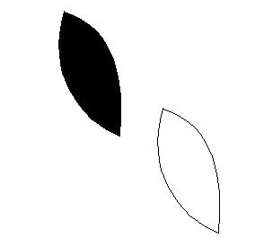 | 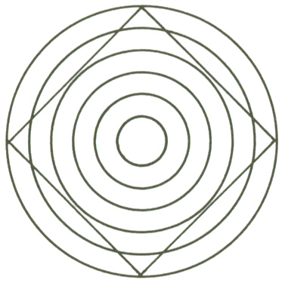 | 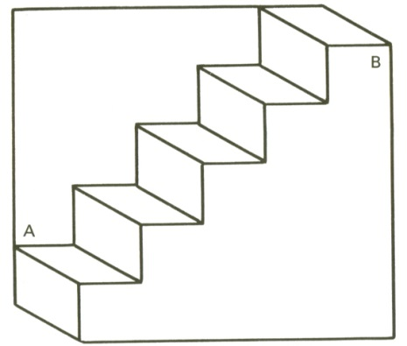 | 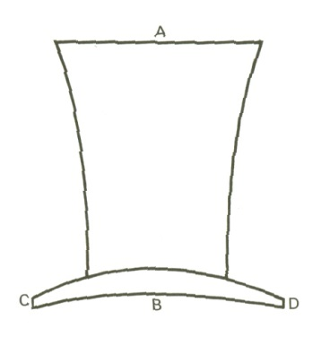
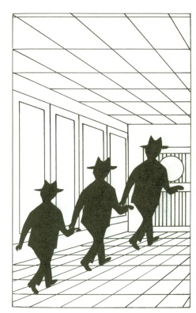 | 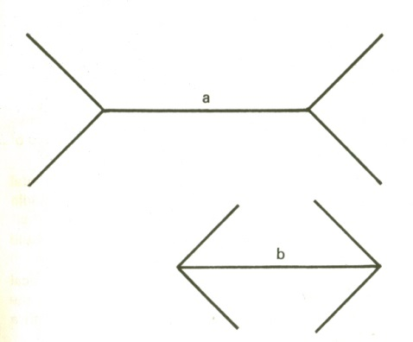 | 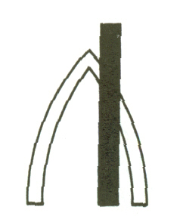 | 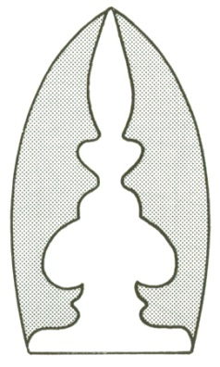
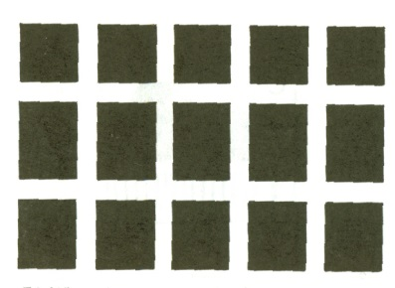 | 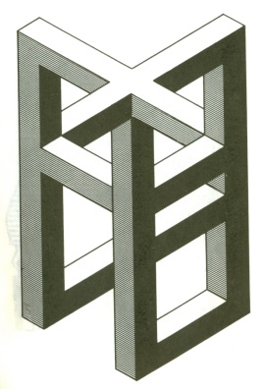 | 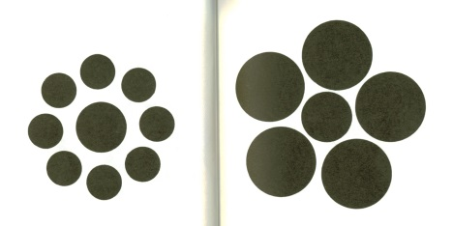 | 