Set: Discovering Patterns
January 3, 2014

Name:_______________________________________________Period:________________

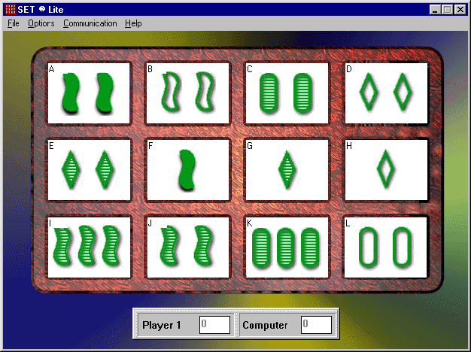
- In the space provided, find at least 8 sets in the following:

Sets:

JAB, FBI, JEC, BDL, HAK, GCI, FDK, CAD, ALE, GJK, GJK
In the space provided, find at least 8 sets in the following:
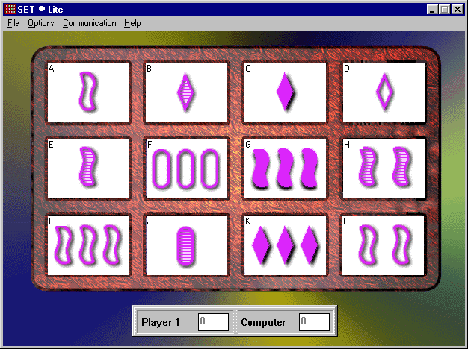

Sets:

BCD, JAC, BEJ, AIL, HAG, CHF, JKL, LEG, DLF

