Minesweeper & Set Test
January 3, 2014

Name:__________________________________Period:_________________

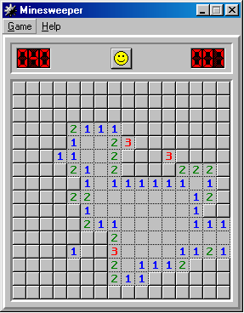
- In the Minesweeper game below, identify the uncovered squares which must be mines with a flag and the uncovered squares which must NOT be mines with an X. (HINT: There are 18 regular mines, 1 advanced mines, 26 regular X’s, and 1 advanced X’s.)

- In the space provided, find 7 sets in the following:

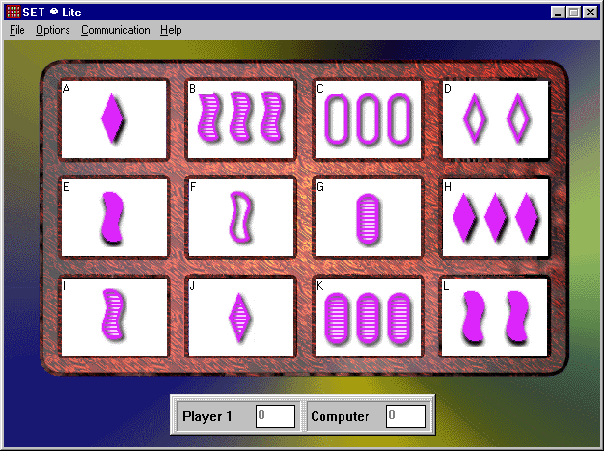
Sets:

