Building Bridges

Group:_______________________________________________Block:____________

Project Essential Questions
- What are the characteristics of the best bridges?
- How is geometry used in bridge construction?
- What knowledge and skills can you as an individual gain from this project that you can use in the future?
Research
- Research various possible bridge designs
- Each group member will select a bridge design that they believe to be the best for this project.
- Decide with your group which design you as a group would like to create. Every member of the group must agree on the final design choice.
- Each group member needs to come up with a resource that supports your group’s design choice.
- Explain key geometric elements that are used in your bridge design.
- Present your design research to the class.
Build Your Bridge
- Ensure that your bridge meets the basic design constraints provided by your teacher.
- Construct your bridge based off of your groups chosen design.
Weight Test
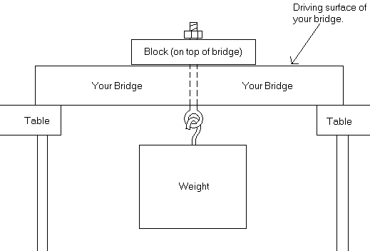
- Each bridge will be tested by hanging weight directly from the center of the bridge. (See diagram below for one possible method for hanging the weight.)

- For this project your bridge must support a minimum weight (designated by the teacher)
- The group whose bridge supports the most weight will receive a prize.

Have FUN!!!
Building Bridges

Group:_______________________________________________Block:____________

Project Analysis and Evaluation

Answer each prompt thoroughly. Be specific.
ESSENTIAL QUESTIONS
- Name and describe at least two characteristics that make the best bridges?
- Name and describe at least two ways that geometry is used in bridge construction?
- What knowledge and skills can you as an individual gain from this project that you can use in the future?
ANALYSIS OF YOUR GROUP’S STRENGTHS AND WEAKNESSES
- Name and describe at least three of your group’s greatest strengths throughout this project. Explain how you could improve upon each of these strengths
- Name and describe at least three of your group’s biggest struggles throughout this project. Explain how you could address these struggles better if given the opportunity to work with the same group again.

ANALYSIS OF BRIDGE’S STRENGTHS AND WEAKNESSES
- Based on the final outcome of your bridge and that of your classmates, what were at least two strengths of your bridge and why do you consider them strengths?
- Based on the final outcome of your bridge and that of your classmates, what are at least two weaknesses of your bridge that you would change if you had the chance to build it again? Explain how these changes would improve the integrity of your design.
ANALYSIS OF THE BRIDGE PROJECT IN GENERAL
- As you think about the entire bridge building project from start to finish, describe at least two modifications that could be made which could make this project even more effective at achieving its goals and purposes for all students participating.

Geometry: Bridge Building Project – Rubric

Group Names:_____________________________________ Block:________________

- Group Drawing AND Research (30 pts)
  - Blueprint of bridge (include end, side, roadbed, and
top views) (20 pts) ________
  - Provide reasoning for bridge choice (5 pts) ________
  - Explanation of key geometric elements of bridge (5 pts) ________
Section 1 SUBTOTAL: _______ / 30
Participation Multipliers: _______
Section 1 FINAL SCORE: _______ / 30
- Group Bridge Construction (40 pts)
  - Built to specifications (see handout) (15 pts) ________
  - Design matches blueprint (15 pts) ________
  - Model is neat and organized (10 pts) ________

Section 2 SUBTOTAL: _______ / 40
Participation Multipliers: _______
Section 2 FINAL SCORE: _______ / 40

- Individual Analysis Essay (30 pts)
  - Each prompt is addressed clearly and completely (25 pts) ________
  - Essay is typed, organized, and clear (5 pts) ________

Section 3 FINAL SCORE: _______ / 30

