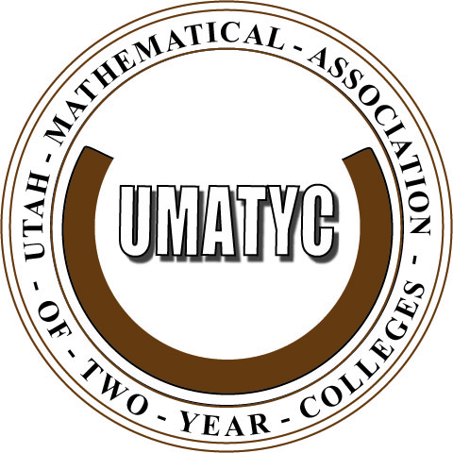
2012 Annual
UMATYC Fall Conference
Saturday, September 15, 2012

Time |  | Location
9:00 – 9:30 am | Registration & Continental Breakfast  Sponsored by | Noyes Building  4th Floor  Founders Hall
9:30 – 10:30 am | Welcome, Introductions, & UMATYC Business | Noyes Building  4th Floor  Founders Hall
10:30 – 11:00 am | “Re-design of Developmental Math” Lorie Hughes & Steve Zollinger, Snow College | Noyes Building  4th Floor  Founders Hall
11:00 – 11:30 am | “Minds of Modern Mathematics iPad App, Plus Movies!” Larry Smith, Snow College | Noyes Building  4th Floor  Founders Hall
11:30 – 12:00 pm | “Developmental Mathematics Program Completion: Traditional Instructions Compared to Computer Based Instruction.” Carrie Quesnell, Weber State University | Noyes Building  4th Floor  Founders Hall
12:00 – 1:00 pm | Lunch & Networking  Sponsored by: iLearn, Inc.   | Noyes Building  4th Floor  Founders Hall
1:00 – 2:00 pm |   “Mastering Math, Not the System” Emily Jones, Hawkes Learning Systems | Noyes Building  4th Floor  Founders Hall
2:00 – 2:30 pm | “$π$ is Wrong: Be 1 with the $τ$” Omel Contreras & Larry Smith, Snow College | Noyes Building  4th Floor  Founders Hall
2:30 – 3:30 pm | “Synthetic Factoring: A Student Centered Approach to Factoring Trinomials.” Jonathan Anderson & Darren Wiberg, Utah Valley University | Noyes Building  4th Floor  Founders Hall
3:30 – 4:00 pm | UMATYC Officers Meeting | Noyes Building  4th Floor  Founders Hall
