2012 Annual
Fall UMATYC Conference
Saturday, September 15, 2012

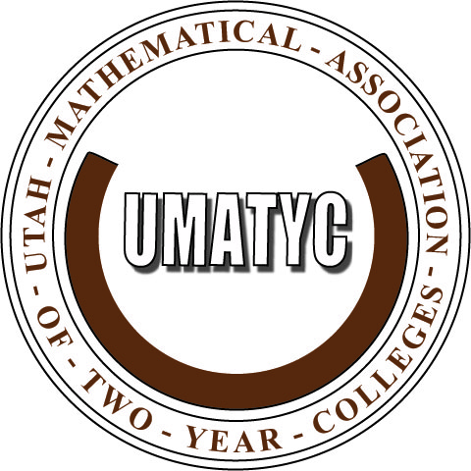


Hosted by:

Ephraim, UT

