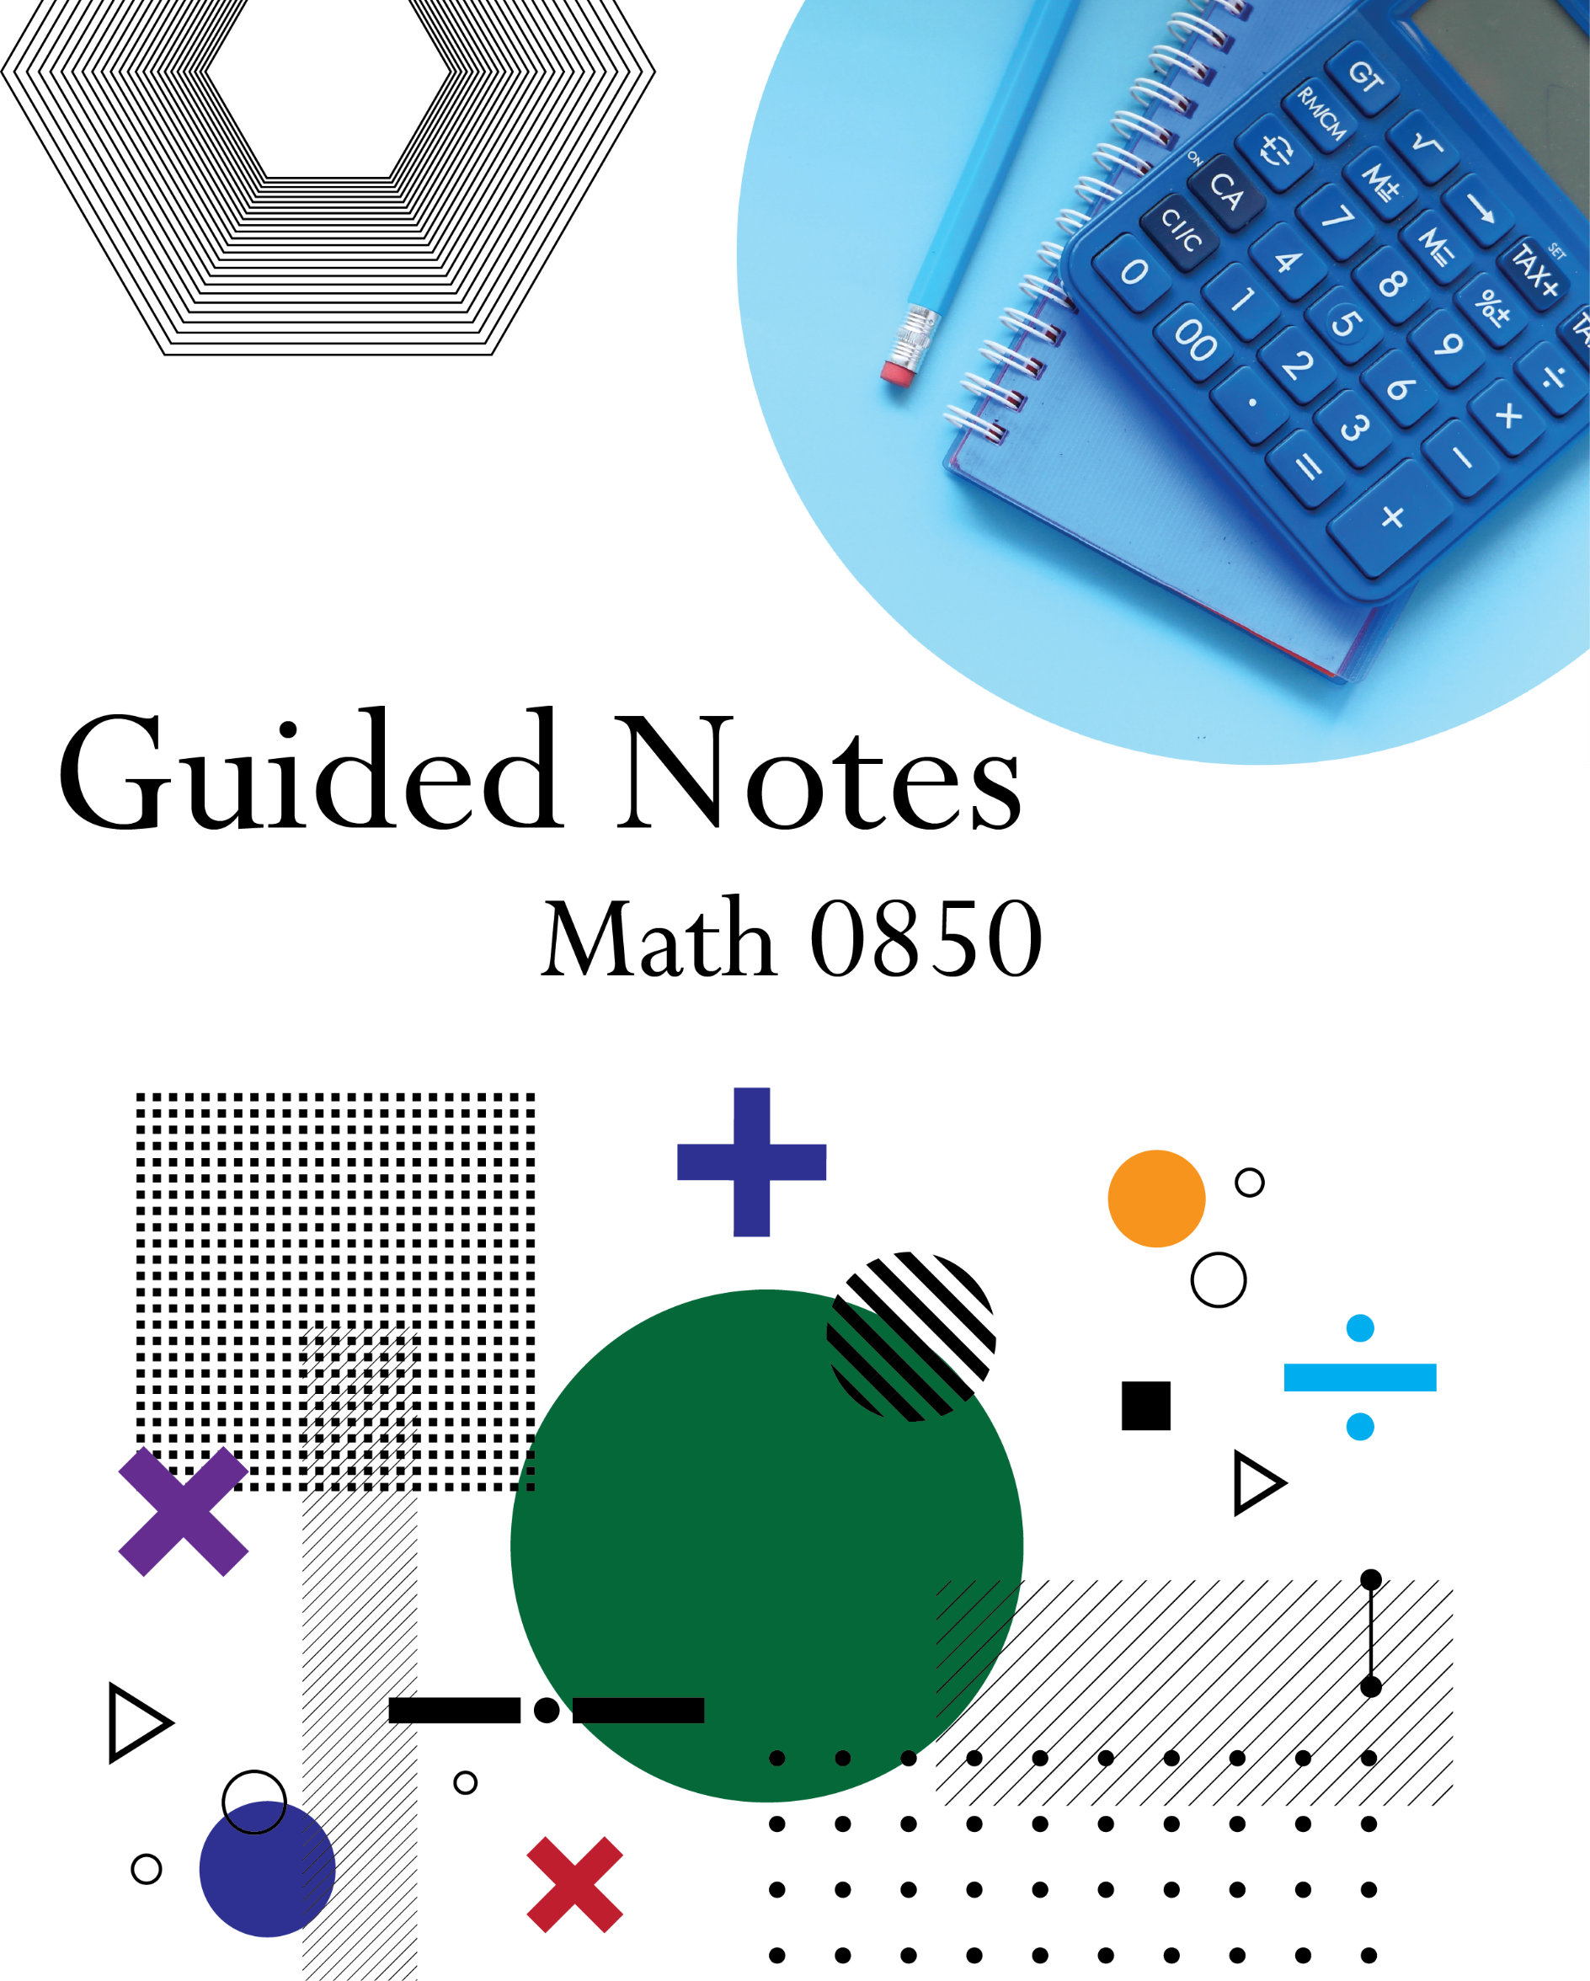
Table of Contents
Unit 1 Building a Foundation 1
1.1 – Addition and Subtraction (Integers) 1
Basics 1
Applications for Signed Numbers 2
Applications with Like Quantities 2
1.2 – Multiplication & Division (Integers) 4
Repeated Addition (Multiplication) 4
Division 5
Applications 5
1.3 – Fractions 7
Basics 7
Arithmetic 8
Applications 9
1.4 – Decimals 11
Connections to Fractions 11
Arithmetic 12
Rounding 13
Applications 14
1.5 – Percentages 15
Basics 15
Fractions, Decimals, and Percentages 16
Applications 17
1.6 – Exponents 19
Repeated Multiplication 19
Exponent Rules 20
1.7 – Order of Operations 21
1.8 – Rectangular Coordinate System 22
Plotting Points 22
Creating Graphs 23
Interpreting Graphs 25
Unit 2 – Charts, Graphs, and Equation Basics 26
2.1 – Understanding and Using Pie Charts 26
2.2 – Understanding and Using Bar Charts 30
2.3 – Area and Volume 34
Units and Formulas 34
2.4 – Dimensional Analysis 44
Imperial and Metric Unit Conversions 44
Rate of Change Conversions 50
2.5 – Scientific Notation 51
Convert Between Standard and Scientific Notation 51
Multiply and Divide Numbers in Scientific Notation 53
2.6 – Expressions 55
Writing and Interpreting Expressions 55
Evaluating Expressions and Formulas 57
Applications 58
2.7 – Equations 61
Solving Equations 61
Proportions 63
2.8 – Linear Inequalities 65
Solving Inequalities and Applications 65
Unit 3 – Lines, Variation, and Distance 73
3.1 – Slope as a Rate of Change 73
Calculate Slope 73
Applications and Interpretation of Slope 75
3.2 – Linear Graphs and Intercepts 76
Graph a Line by Plotting Points 76
Finding Intercepts 78
Interpreting Intercepts 80
3.3 – Equations of Lines 81
Slope–Intercept Form 81
Write a Linear Equation from a Graph 81
Write a Linear Equation Given Slope and Intercept 82
Write a Linear Equation Given Two Points 83
3.4 – Applications Using Linear Equations 84
Independent and Dependent Variables 84
Applications 85
3.5 – Variation 87
Identify Direct and Inverse Variation Situations 87
Write a Direct and Inverse Variation Equation for Situations 88
Applications of Variation 89
3.6 – Pythagorean Theorem 91
Pythagorean Theorem 91
Square Root Basics 92
Applications 93
3.7 – Distance Formula 94
Distance Formula 94
Applications 95
Unit 4 – Data and Statistics 96
4.1 – Probability 96
Basic Probabilities 96
Probability vs. Percent Chance 98
Theoretical vs. Experimental Probabilities 99
4.2 – Data Gathering and Organization 101
Population vs. Sample 101
Scatter Plots 102
Frequency Distributions 104
Histograms 105
Stem and Leaf Plot 107
4.3 – Beginning to Analyze Data 109
Measures of Center 109
Weighted Averages and Grades 110
Standard Deviation 111
68–95–99.7 Rule (aka Empirical Rule) 113
4.4 – Linear Regression 116
Linear Correlation 116
Line of Best Fit 120
Unit 5 – Exponential and Quadratic Equations 123
5.1 – Functions 123
Identifying Functions 123
Function Notation 125
5.2 – Algebraic Expressions 126
Addition and Subtraction of Algebraic Expressions 126
Multiplication of Algebraic Expressions 127
Revenue, Cost, and Profit 129
5.3 – Quadratic Functions 135
Quadratic Graphs and Applications 135
Factoring to Find Zeroes 140
Quadratic Formula to Find Zeros 144
Vertex of Quadratic Functions 146
5.4 – Exponential Models 147
Compound Interest 147
Other Exponential Growth 149
Exponential Decay 150
Comparing Exponential and Linear Growth 151
5.5 – Exponential Regression 156
5.6 – Logarithms 159
Introduction to Logarithms 159
Change of Base 161
Applications 162

Unit 1 Building a Foundation

1.1 – Addition and Subtraction (Integers)

Basics

Explain how to simplify an expression involving the addition and subtraction of integers.

 Practice

- $3+15=$
- $4+\left(-12\right)=$
- $\left(-15\right)+7=$
- $\left(-23\right)+\left(-10\right)=$
- $9-5=$
- $11-\left(-8\right)=$
- $\left(-5\right)-2=$
- $\left(-30\right)-\left(-23\right)=$

Applications for Signed Numbers

Describe some real-world situations that involve adding and subtracting integers.

Practice

- When the pool opens, Carl notices that the temperature of the pool water is $86° F$. Carl wants to bring the temperature down. Therefore, he adjusts the thermostat. One hour after the thermostat adjustment, the water temperature decreased by 5 degrees. What is the new temperature of the pool water?
- Connor currently has $600 in his checking account. He deposits $90. Then he uses his debit card to pay $150 for his groceries. How much money is in Connor’s account after the deposit and debit?

Applications with Like Quantities

Explain the requirements for you to add or subtract two quantities.

Practice

- On Monday, Jimmy ran 5 miles in the morning and 3 kilometers in the evening. $1 mile=1.61 kilometers$
  - How many miles did Jimmy run total on Monday?
  - How many kilometers did Jimmy run total on Monday?
- Lisa is 5 feet and 10 inches tall. She stands on a stool that is 15 inches tall.
  - What is the total height (in feet) when Lisa is standing on the stool?
  - What is the total height (in inches) when Lisa is standing on the stool?

1.2 – Multiplication & Division (Integers)

Repeated Addition (Multiplication)

Explain how to simplify an expression involving multiplication or repeated addition of the same integer.

Practice

- $3+3+3+3+3+3=$
- $\left(-4\right)+\left(-4\right)+\left(-4\right)=$
- $5+5+5+5=$
- $6⋅8=$
- $10⋅11=$
- $3⋅(-5)=$
- $\left(-7\right)(12)=$
- $(-2)(-3)=$

Division

Explain how to simplify an expression involving the division of integers.

Practice

- $50÷10=$
- $99÷\left(-3\right)=$
- $\left(-36\right)÷12=$
- $\left(-72\right)÷\left(-8\right)=$

Applications

What are some tips and strategies to use when solving application or word problems involving the multiplication or division of integers?

Practice

- Marie is training to run a half marathon. As part of her training, she plans to run 7 miles each week. Based on this plan, how many weeks will it take Marie to run 28 miles total?
- Ellie plans to save $30 every month for 2 years. If she follows her plan for 2 years, how much money will she have saved?

1.3 – Fractions

Basics

What is the numerator and denominator of a fraction?

Explain the differences and similarities between improper fractions and mixed numbers.

Explain how to simply a fraction.

What are equivalent fractions?

Practice

- Simplify $\frac{6}{12}$.
- Simplify $\frac{36}{5}$.
- Simplify $3\frac{16}{20}$.
- Find the missing number in the equation $\frac{2}{7}=\frac{?}{35}$.

Arithmetic

Explain how to simplify an expression involving fraction arithmetic.

Practice

- $\frac{1}{8}+\frac{3}{5}=$
- $3-\left(-\frac{2}{9}\right)=$
- $\left(-\frac{4}{3}\right)+\frac{7}{6}=$
- $\left(-\frac{6}{7}\right)+\left(-\frac{2}{3}\right)=$
- $-3\frac{1}{2}+5\frac{1}{4}=$
- $\frac{2}{5}⋅4=$
- $-\frac{3}{8}⋅\frac{8}{3}=$
- $-\frac{4}{9}÷\left(-\frac{2}{3}\right)=$
- $\frac{3\frac{1}{3}}{2\frac{1}{4}}=$

Applications

What are some tips and strategies to use when solving application or word problems involving fraction arithmetic?

Practice

- Janet walked ½ mile on Friday and ¾ mile on Saturday. How far did she walk on Friday and Saturday combined?

- On Tuesday, Hans ate $\frac{3}{8}$ of a pizza for lunch and twice that amount of pizza for dinner. How much pizza did he eat altogether on Tuesday.
- Sariah has $10\frac{1}{2}$ cups of flour. Then she uses $5\frac{2}{3}$ cups of flour baking bread. How much flour does Sariah have left?
- As part of his training for a mountain bike race, Jorge wants to ride $33\frac{1}{3}$ miles during the next 4 days. If he rides the exact same number of miles each day, how many miles does he ride in one day?

1.4 – Decimals

Connections to Fractions

Label the place value of each digit in the number below.
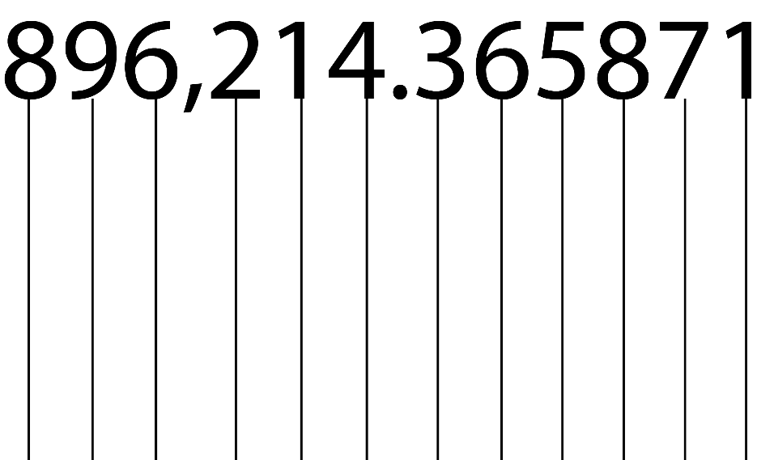

Explain the relationship between fractions and decimals.

Explain how to convert a fraction to a decimal.

Explain how to convert a decimal to a fraction.

Practice

Convert each fraction to a decimal and each decimal to a fraction. Round decimals to two decimal places if needed.
- $\frac{5}{6}$
- $\frac{8}{7}$
- $3\frac{1}{2}$
- $0.75$
- $2.45$

Arithmetic

Explain how to perform decimal arithmetic.

Practice

Perform the decimal arithmetic as indicated.
- $5.671+0.031$
- $3.701-2.005$
- $0.786∙2.78$
- $87.671÷0.031$

Rounding

Explain how to round a decimal number to a certain place value.

Practice

Round each decimal to the indicated place value.
- Round 0.0521 to the hundredths place.
- Round 37.576 to the ones place.
- Round 876.967 to the tenths place.
- Round 672 to the hundreds place.

Applications

What are some tips and strategies to use when solving application or word problems involving decimal arithmetic.

Practice

- You have $725.32 in your bank account. You spend $65.14 on groceries, $32.99 on a new shirt, and $71.89 on a new video game. How much money do you have left in your account.

- You bought 6 apples at the store for $4.50. How much did each apple cost?

1.5 – Percentages

Basics

Explain how to find a certain percentage of a number.

Explain how to find what percentage of a total amount a certain number is.

Explain how to find the total amount when given a percentage and the part of the total that is represented by that percentage.

Practice

Find the given percentages.
- What is 25% of 75?
- What is 36% of 328?
- What is 65% of 500?
- What percent of 200 is 115?
- What percent of 918 is 347?
- What percent of 35 is 15?
- 15% of what number is 115?
- 81% of what number is 60?
- 98% of what number is 243?

Fractions, Decimals, and Percentages

Explain how to convert a percentage to a decimal.

Explain how to convert a decimal to a percent.

Practice

- Convert 67% to a decimal and a fraction.
- Convert 23.9% to a decimal and a fraction.
- Convert 0.943 to a percent and a fraction.
- Convert 1.46 to a percent and a fraction.
- Convert $\frac{7}{12}$ to a decimal and a percent.
- Convert $\frac{32}{13}$ to a decimal and a percent.

Applications

What are some tips and strategies to use when solving application or word problems involving percentages?

Practice

- After dining out, your bill comes to a total of $45.15. You want to leave your server a nice tip of 22%. How much will the tip be and how much will your total bill be after the tip? Round your answers to the nearest cent

- While shopping for clothes, you find a nice shirt that is advertised as 30% off. If the shirt’s regular price is $32.99, what is the sales price of the shirt? Round your answer to the nearest cent.

- In your shop you sell books at a 40% markup on the wholesale price that you purchase them for. If you are selling a particular book for $25.99, how much did you originally pay for the book? Round your answer to the nearest cent.

- Your friend bought a new pair of jeans for $75. You thought this was too much money to pay for jeans, but your friend was excited because they had gotten them for 25% off. What was the original price of the jeans?

- You got your first exam back from your teacher and you see that you scored 35 out of a total of 50 points. What percent did you earn on the test?

1.6 – Exponents

Repeated Multiplication
Explain what an exponent is.

Practice

- Write each expression as a power (a^{b}) and then evaluate the expression.
  - $\left(9\right)\left(9\right)\left(9\right)\left(9\right)\left(9\right)$
  - $\left(3\right)\left(3\right)\left(3\right)$
  - $\left(2\right)\left(2\right)\left(2\right)\left(2\right)\left(2\right)\left(2\right)\left(2\right)\left(2\right)$
- Write each expression as repeated multiplication, then evaluate the expression.
  - $5^{4}$
  - $8^{7}$

Exponent Rules

Complete each of the exponent rules.
- Zero Exponent: $a^{0}=$
- Identity Exponent: $a^{1}=$
- Product Rule: $a^{m}×a^{n}=$
- Quotient Rule: $\frac{a^{m}}{a^{n}}=$
- Negative Exponents: $a^{-m}=$
- Power of a Power: ${\left(a^{m}\right)}^{n}=$
- Power of a Product: ${\left(ab\right)}^{m}=$
- Power of a Quotient: ${\left(\frac{a}{b}\right)}^{m}=$

Practice

Simplify each expression by using the exponent rules above.
- ${\left(-2x\right)}^{3}\left(5x^{-2}y^{0}\right)$
- $\frac{6x^{-3}y^{5}}{x^{4}y^{3}}$
- ${\left(-x^{1}y^{3}\right)}^{5}$
- ${\left(-5\right)}^{2}$
- $-5^{2}$

1.7 – Order of Operations
Explain what the order of operations is and why it is important.

Practice

Use the order of operations to simplify each of the expressions.
- $18÷3∙2+6^{2}-5$

- $\left(5+3^{2}\right)-10{\left(25÷5\right)}^{2}$

- $\frac{7∙3-5}{3+1^{3}}$

- $\left(8-\left(12÷3∙6\right)\right)÷8+1$

1.8 – Rectangular Coordinate System

Plotting Points

Explain what the rectangular coordinate system is.

Explain what it means to plot a point.

Practice

- Plot each of the points on the rectangular coordinate grid below.
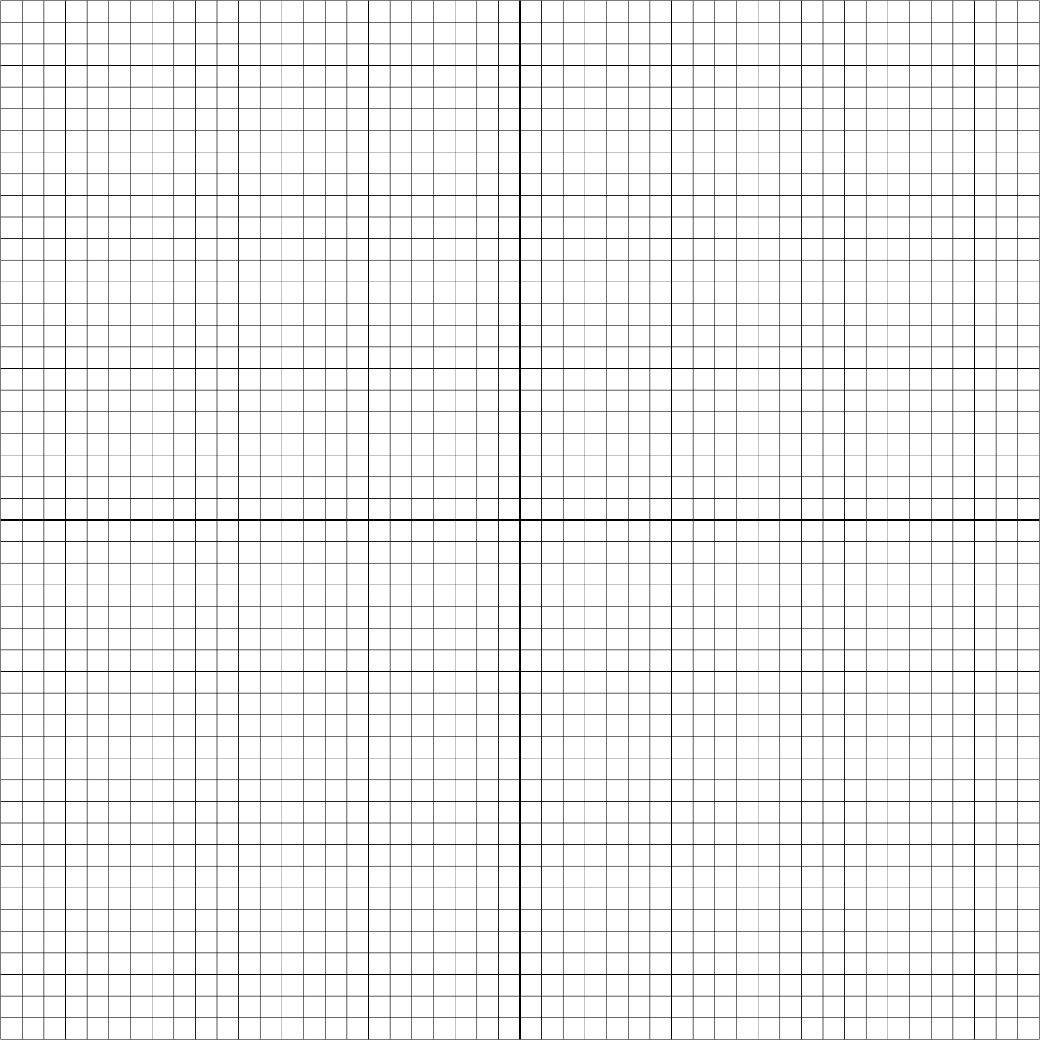
- (–5, 2)
- (9, 1)
- (0, 0)
- (–3, –2)
- (4, –5)

- Identify the coordinates of each of the points on the grid below.

Creating Graphs

Explain what elements make a good graph.

Practice

Identify what is confusing or misleading about each of the graphs below. If nothing is confusing or misleading, then indicate put NA as your answer.

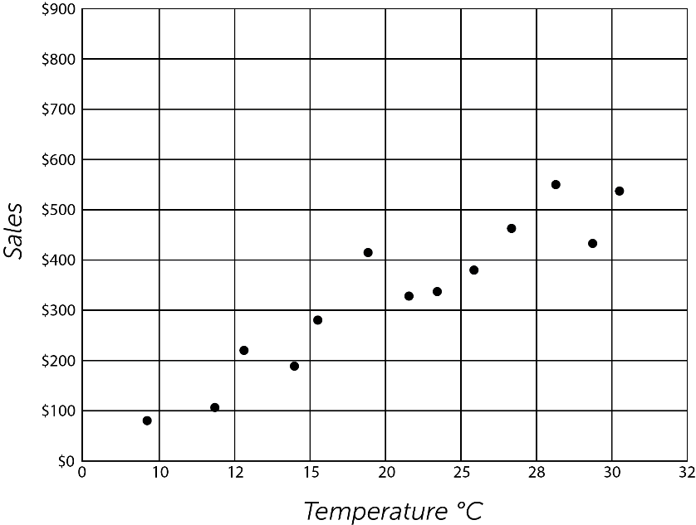
- Ice cream sales graph

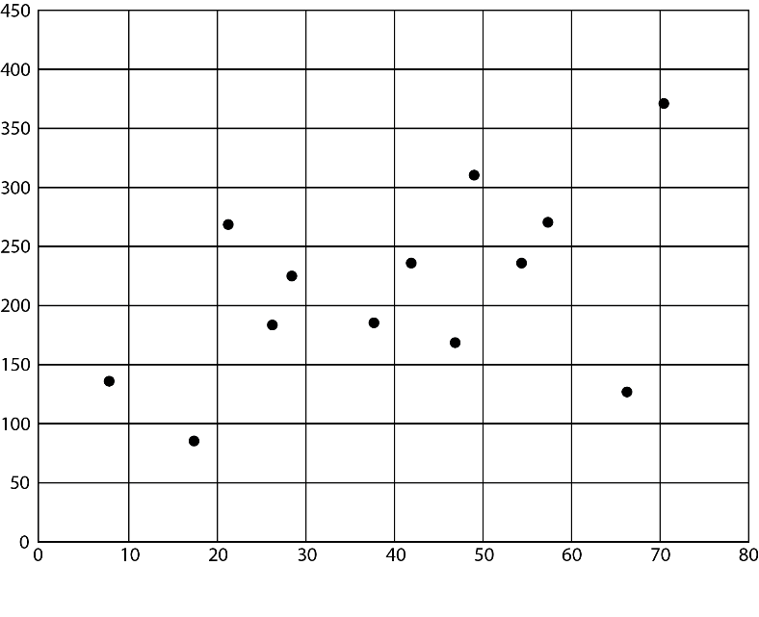
- Graph

Interpreting Graphs

Use the graph to answer the questions.
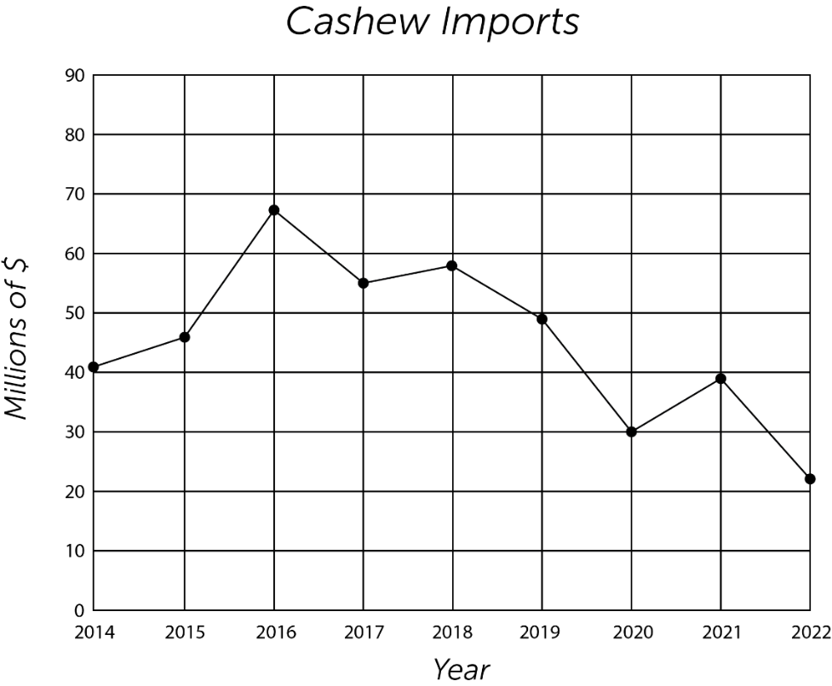

- When did the amount spent on cashew imports increase?

- When did the amount spent on cashew imports decrease?

- From 2016 to 2022, was the amount spent on cashew imports generally increasing or generally decreasing?

Unit 2 – Charts, Graphs, and Equation Basics

2.1 – Understanding and Using Pie Charts



What are some key features of the pie chart above?
Why is it called a “pie chart”?

When do you use a pie chart?

What are the requirements for using a pie chart?

How do you read a pie chart?

To create a pie chart, we first need to understand an idea known as a central angle.

Definition
Central Angle

Each slice in the pie chart will be constructed using a central angle. The actual angle will be determined by the proportion.
How many degrees are in a circle?

Then if a certain category was exactly 50% of the data, how many degrees should it use?

Steps to Create a Pie Chart
- For each category, calculate the proportion of the whole.
- For each category, find the central angle for each category by multiplying the proportion by 360 degrees.
- For the first category, draw a line segment from the center to the 0 degrees mark. Draw another line segment at the central angle for that category. The slice is between the two segments.
- For each subsequent category, add the central angle amount to angle of the previous line segment.
- For each category, write down the name of the category and the percentage. This can be between the segments, off to the side, or in a legend.

Practice

- As a class, we will take a survey. Answer the question: “which of the following choices is your favorite ice cream flavor?” Make a pie chart.
Flavor | # of People | Fraction | Proportion | Central Angle Degrees
Vanilla

Chocolate

Swirl

Other

Total

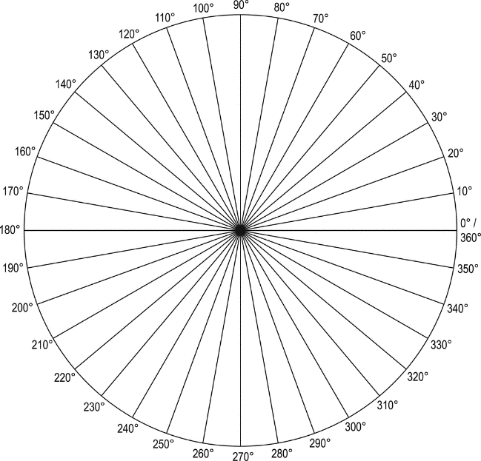

Flavor | # of People | Fraction | Proportion | Central Angle Degrees
Vanilla
Chocolate
Swirl
Other
Total
- As a class, we will take another survey. This one is similar but slightly different. This time you may vote more than once or not at all. For each flavor, answer the question: “Do you like [insert ice cream flavor]?”.
Why can’t we make a pie chart with this data?

2.2 – Understanding and Using Bar Charts

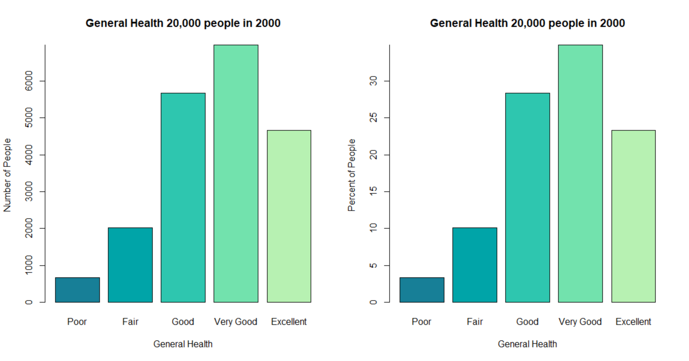
What are some key features of the bar charts above?
Why are they called “bar charts”?

When do you use a bar chart?

What are the requirements for using a bar chart?

How do you read a bar chart?

Steps to Create a Vertical Bar Chart

- Draw a 2D axis system.
- On the x–axis (the horizontal axis), write the category names. Leave equal space between each category name.
  - If there is a natural ordering the categories (very unhappy, somewhat unhappy, neutral, somewhat happy, very happy), order the categories that way
  - If there is not an ordering, it is customary to put them in descending order (largest to smallest)
- On the y–axis (the vertical axis), draw equally spaced tick marks and label them. The range of data you need to show should determine the numbers. The y–axis should always start at 0 and the top should be at or above your highest value. Use human readable numbers (ex: go by 5s or 10s) rather than the actual data for your tick marks.
  - Example: If you are showing percentages and your percentages are 22%, 26% and 37%, your tick marks might be at 5%, 10%, 15%, 20%, 25%, 30%, 35%, and 40%
- For each category, draw and shade a rectangle. The width of each rectangle should be the same and the height should match the data.
- Label the axes and/or give your plot a nice title to explain what the reader is looking at.

Practice

Flavor | # of People | Fraction | Proportion
Vanilla
Chocolate
Swirl
Other
Total
- Let’s copy the “Do you like [insert ice cream flavor]?” data from the previous lesson and create a vertical bar chart of percentages.
A bar chart can be a bar chart of percentages or a bar chart of counts (the actual numbers). In the previous example, what would be different in a bar chart of counts? What would be the same?
Bar charts can also be shown horizontally where the bars go horizontally, and the categories are on the vertical axis. How would we create a horizontal bar chart?

- Working with your group, create a horizontal bar chart of the ice cream data.

Genre | # of People | Fraction | Proportion
Rock
Pop
Country
Classical
Total
- As a class, we will take another survey. You may vote more than once or not at all. For each genre, answer the question: “Do you like [genre] music?” Make a bar chart with your group.
Could we make a pie chart with the previous data? If not, why not?

2.3 – Area and Volume

Units and Formulas

Area of a Rectangle

Suppose you want to tile your bathroom floor which is 8 feet long and 5 feet wide and represented by the shape below. What shape is it?

Explain how to find the area of your bathroom floor.
How do you determine the proper units to use for area?

Formula
Area of a Rectangle

Formula
Area of a Square

Practice

- You are considering a paver patio for your backyard. The shape you want is a 12 foot by 16 foot rectangle. Draw it and calculate the area.
What must you do if the units for the length and width do not match?

- You are buying glass for a window. The window is 2 feet wide and 3 feet 6 inches tall. Draw it and calculate the area.

- You are building a house with a loft room on the 2nd floor. You want to put carpet on the floor is 14 feet by 14 feet. How much carpet, in square feet, is needed?

Area of a Triangle

What shapes do we get if we take our 8 ft x 5 ft rectangle and cut it in half diagonally?

What is the area of each shape?

Formula
Area of a Triangle

Practice

- You are building a house with a loft room on the 2nd floor. The loft room has a gable roof (triangular) and you want to buy a window to fit. The window is to be a triangle 4 feet long and 3 feet tall. Draw a picture and calculate the surface area of the glass.

Area of a Circle

What about a strange shape like a circle? Consider this 2 foot by 2 foot square with a circle inside.

Will the area of the circle be the same, less, or more than the square?

What is the diameter of a circle?

What is the radius of a circle?

What is the value of $π$ (pi)?

Formula
Area of a Circle

Practice

- You are considering building a flagstone patio around your fire pit in your backyard but can’t decide between square or circular. You want it to take up an 8 feet by 8 feet area. It can be an 8x8 square or a circle with diameter 8 feet. Draw and calculate the area of each.
- Which has more area, circle 1 which has a radius of 7 cm or circle 2 which has a diameter of 10 cm?
- When you buy pizza, the size is referring to the diameter of the pizza. Suppose you and a friend are buying pizza. A personal pizza is 8” and costs $10. A large pizza is 16” and costs $20. Whether you each buy a personal pizza or split a large pizza together, it will cost $20. Which option gets you more pizza?
- In general, how much more pizza will you get if you double the size of the pizza? If you are stuck, try out a few possibilities.

Volume of a Box

Consider the box below which is 4 cm wide, 3 cm tall, and 2 cm deep.

What are some real-life objects that have this shape?

Explain how to find the volume of this box.

How do you determine the proper units to use for volume?

Formula
Volume of a Box

Practice

- According to Home Depot, the most commonly used moving box is the medium size which actually comes in two styles: style 1 is 18 inches by 18 inches by 15 inches. Is this a box or cube? Draw it and calculate the volume.
- Style 2 of the medium box is a little taller but a little less wide. It is 22 inches by 16 inches by 15 inches. Draw it and calculate the volume. Which style of box holds more stuff?
- Suppose a box was 18 inches by 18 inches by 18 inches. Is this a box or cube? Which formula would you use to calculate volume? Calculate it.

Volume of a Cylinder

The cylinder below has a radius of 4 inches and a height of 5 inches.

What are some real-life objects that have this shape?

Explain how to find the volume of this cylinder.

Formula
Volume of a Cylinder

Practice

- The standard container for a gallon of paint has a diameter of 6.5 inches and a height of 7.4 inches. Draw it and calculate the volume.
- Suppose a cylindrical water tower has a radius of 10 meters and is 100 meters tall. Draw it and calculate how much volume of water it holds, in cubic meters.

Volume of a Sphere

The sphere below has a radius of 10 miles.

What are some real-life objects that have this shape?

Explain how to find the volume of this sphere.

Formula
Volume of a Sphere

Practice

- A men’s basketball is about 24 cm in diameter. How much air can fit in a basketball, if completely pumped up?

- A ping pong ball has a radius of 2 cm. Take a guess how many ping pong balls can fit in a basketball.
- Calculate the volume of air that can fit in a ping pong ball.
- How many ping pong balls could fit in a basketball? To find out, divide the result in example 15 by the result in example 17. (This assumes you could use all available space in the basketball).
- Was the previous result surprising? A basketball has a radius of 12 cm. That is only 6 times as large as the 2 cm radius of a ping pong ball. Then why can it fit 216 ping pong balls?

2.4 – Dimensional Analysis

Imperial and Metric Unit Conversions

You are car shopping in England and the car you are looking at says the gas mileage is 6.5 L / 100 km. Is that good or bad gas mileage?
You are in Mexico and a vendor is selling a nice blanket for 400 pesos. Is that a lot of money or not?
The German Autobahn does not have an official speed limit. Instead it has an “advisory speed limit” of 130 km per hour. Is that fast?
You are at the store to buy mulch. You know your garden is 20 square yards but the mulch sells by the square foot. How many square feet of mulch do you need?

The quantities 1 inch and 2.54 cm represent the same distance. How would you convert 15 inches to cm?

How would you convert 15 cm to inches?

How do you know when to multiply and when to divide?

Definition
Dimensional Analysis

Definition
Unit Rate

How do you create a unit rate from two related values?

Definition
Conversion Factor

Basic Process to Perform a Dimensional Analysis

- Write down the given information.
- Identify the goal.
- Identify the conversion factor(s) you will need to convert from the given to the goal. It may help to write them down.
- Setup a multiplication of fractions.
  - Write down your given info as a fraction. If it is just a single quantity, write it as a fraction over 1.
  - Using the needed conversion factors, create a series of multiplications such that the units you want remain in the correct place and the units you don’t want cancel out.
- Multiply the numbers through the numerator. Multiply the numbers through the denominator. Divide the numerator by the denominator. Keep any units that are not canceled out.

Table of Conversion Factors
Length | Volume | Time | Mass / Weight
12 in = 1 ft | 3 teaspoons = 1 tablespoon | 60 seconds = 1 minute | 1 kg = 1000 g
3 ft = 1 yd | 8 oz = 1 cup | 60 minutes = 1 hour | 16 oz = 1 lb
5280 ft = 1 mi | 2 cups = 1 pint | 24 hours = 1 day | 2.2 lb = 1 kg
1 mi = 1.61 km | 2 pints = 1 quart | 7 days = 1 week | 28.3 g = 1 oz
2.54 cm = 1 inch | 4 quarts = 1 gallon | 52 weeks = 1 year
1 m = 3.28 ft | 3.79 L = 1 gallon | 365 days = 1 year
1 km = 1000 m | 1 L = 1000 mL
 | 1 cc = 1 ${cm}^{3}$ = 1 mL

Practice

- Jeff drove 336 miles in 4 hours. What was his average speed as a unit rate in miles per hour?
- At Walmart, a package of 10 Oscar Mayer Beef hot dogs costs $2.84. What is cost of each hot dog (find the unit rate)?

- Ann drove 275 miles then refilled her gas tank with 12.3 gallons. What was her gas mileage in miles per gallon?
- At Walmart, a package of 8 Grandma Sycamore hot dog buns costs $2.68. How much does each hot dog bun cost?
- A pizza is cut into 8 equal slices. In terms of eighths, what fraction of the pizza is ½?
- The average offensive lineman in the NFL weighs 141.3 kg. How many pounds is that?
- Who has run a 5K race? How many miles? Let’s convert with dimensional analysis.
- A nurse is to deliver 120 mg of Acetaminophen (Tylenol) to a newborn in a 80 mg per 5 mL suspension. How many mL of Tylenol does she deliver total?

- How many seconds are in a day?
- Suppose you want to buy something in another country using their currency. How do you know if it is a good deal?
- You are considering a trip to Japan, but you are concerned that hotel costs 15,000 Japanese Yen per night. Is that a lot of money or not? Look up the conversion rate, make the conversion, and decide.

Area and Volume

Explain how to do dimensional analysis when dealing with units of area (e.g. ft²) or volume (e.g. m³).

Practice

- The city of Ephraim covers 4.45 square miles. How many square km is that?
- According to Wikipedia, a standard Olympic pool contains $2500 m^{3}$ of water. How many cubic feet is that?

Rate of Change Conversions

Explain how to do dimensional analysis when dealing with rates of change (e.g. miles per hour).

Practice

- According to Wikipedia, the German Autobahn does not have an official speed limit. Instead, it has an “advisory speed limit” of 130 km per hour. Convert that to miles per hour. Compare to local speed limits.

2.5 – Scientific Notation

Convert Between Standard and Scientific Notation

Powers of Ten

 | Value | Fraction
${10}^{4}$ | $10000$
${10}^{3}$ | $1000$
${10}^{2}$ | $100$
${10}^{1}$ | $10$
${10}^{0}$ | $1$
${10}^{-1}$ | $.1$ | $$\frac{1}{{10}^{1}}$$
${10}^{-2}$ | $.01$ | $$\frac{1}{{10}^{2}}$$
${10}^{-3}$ | $.001$ | $$\frac{1}{{10}^{3}}$$
${10}^{-4}$ | $.0001$ | $$\frac{1}{{10}^{4}}$$
Notice two patterns:
- When the exponent is positive, the overall value is _____ than 1.

- When the exponent is negative, the overall value is _____ than 1.

Important Rules of Exponents Applied to Powers of Ten

Exponent Rule Powers of 10 Examples
$a^{b}⋅a^{c}=a^{b+c}$ ${10}^{8}⋅{10}^{2}=$

$\frac{a^{b}}{a^{c}}=a^{b-c}$ $\frac{{10}^{9}}{{10}^{5}}=$

Explain the basic format and meaning of scientific notation.
When is it most beneficial to use scientific notation?

Rules for moving the decimal between Scientific and Standard Notation

Decimal moves left, exponent goes ______. Decimal moves right, exponent goes _____.

Practice

- Fill in the missing values in the table below.
Scenario | Standard Notation | Scientific Notation
Distance from Earth to the moon | 238,900 miles
Average distance from Earth to the sun |  | $9.296×{10}^{7}$miles
Distance around the Earth at the equator | 24,901 miles
The average diameter of a COVID–19 virus | 0.0000001 meters
The average length of an E. coli bacteria |  | $7×{10}^{-6}$ meters
The average distance between fibers on a cloth mask |  | $1×{10}^{-4}$ meters

Multiply and Divide Numbers in Scientific Notation

Steps to Multiply Numbers in Scientific Notation
Multiply $(a×{10}^{n})(b×{10}^{m})$
- Multiply $a*b$
- Multiply ${10}^{n}*{10}^{m}$ by adding exponents
- Put your answer in the notation requested

Steps to Divide Numbers in Scientific Notation
Divide $\frac{a×{10}^{n}}{b×{10}^{m}}$
- Divide $a÷b$
- Divide $\frac{{10}^{n}}{{10}^{m}}$ by subtracting exponents
- Put your answer in the notation requested

Practice

- Multiply and write the product in scientific notation.
$\left(2.4×{10}^{3}\right)\left(5×{10}^{-4}\right)=$
$6.8⋅\left(3×{10}^{5}\right)=$
- Multiply and write the product in standard notation.
$\left(3.03×{10}^{4}\right)\left(1.9×{10}^{9}\right)=$
- Divide and write the quotient in scientific notation.
$\frac{5×{10}^{7}}{2×{10}^{2}}=$ $$\frac{9×{10}^{8}}{4.2×{10}^{5}}=$$

2.6 – Expressions

Writing and Interpreting Expressions

Definition
Expression

Definition
Coefficient

Definition
Variable

Definition
Constant

What words or phrases represent each of the following mathematical operations or concepts.

Addition:

Subtraction:

Division:

Multiplication:

Equals:

Practice

Translate each phrase into an algebraic expression. Use variables for any unknown quantities.
- Three times a number plus one.
- The sum of a number and five.
- Three less than twice a number.
- The product of a number and 7.
- The difference between a number and 10.
- The quotient of a number and 6.

Evaluating Expressions and Formulas

What are some tips and strategies to use when evaluating algebraic expressions and formulas?

Practice

Evaluate each of the expressions.
- $2x+1 for x=5$
- $3x^{2}+4x-5 for x=2$
- $7w+2z for w=1 and z=3$
- ${\left(x+y\right)}^{2} for x= -2 and y=4$

Applications

Common Formulas and their Meanings
$$C = πd=2πr$$  C = circumference  $π$ = 3.14  d = diameter  r = radius | $$r$$  $$d$$ | The circumference ($C$), or perimeter of a circle is equal to the product of pi ($π$) and the diameter ($d$).  Or, the circumference ($C$) of a circle is equal to twice the product of pi ($π$) and the radius ($r$).
$$P=2l+2w$$  P = perimeter  l = length  w = width | $$l$$  $$w$$ | The perimeter ($P$) of a rectangle is equal to twice the length ($l$) and twice the width ($w$).
$$C=\frac{5}{9}(F-32)$$  C = temperature in $℃$  F = temperature in $℉$ |  | The temperature indegrees Celsius ($C$) is equal to $\frac{5}{9}$ of the difference between the Fahrenheit temperature ($F$) and 32.
$$d=rt$$  d = distance  r = rate  t = time |  | The distance ($d$) traveled is equal t the product of the rate of speed ($r$) and the time ($t$).
$$I = Prt$$  I = Simple Interest  P = Principal (original)  r = rate (%)  t = time in years |  | The simple interest ($I$) earned investing money is equal to the product of the principal ($P$), the percentage rate of the interest ($r$), and the time in years or fractions of years ($t$).
$$A=P+Prt$$  A = amount earned  P = principal (org amount)  r = rate (%)  t = time in years |  | The amount of money (A) earned on an account is the sum of the principal amount (P) and the interest earned (the product of principal, rate, and time)
$$α+β+γ=180°$$  $α=$ angle 1  $β=$ angle 2  $γ=$ angle 3 | $$γ$$  $$β$$  $$α$$ | The sum of the measures of the angles ($α,β, \text{and }γ)$ of a triangle is $180°$

Practice

- Newton’s second law can be described using the formula $F=ma$, where $F$ is force, $m$ is mass, and $a$ is acceleration. Use this formula to find the acceleration ($m/s^{2}$) of a car that has a mass of 1000kg and a force of 5000 Newtons.

- Ken borrows $300 dollars from his grandma to help pay for his textbooks for the semester. She charges him 2% simple interest on the loan. In four years when Ken graduates, how much interest on the loan does Ken owe his grandma?
How much total money does Ken owe his grandma after four years?

2.7 – Equations

Solving Equations

Definition
Equation

Definition
Term

Definition
Solution to an Equation

Definition
Solving an Equation

Principles of Solving an Equation
 | Symbols | Words
Addition Principle
Subtraction Principle
Multiplication Principle
Division Principle

Steps to Solving Equations

Practice

Solve each equation.

- $5x+3=2x-15$
- $18+4x=2x-12$
- $3\left(x-5\right)=-x+21$
- $\frac{1}{5}x+\frac{1}{10}x-3=\frac{1}{2}x$

Proportions

Definition
Ratio

Definition
Proportion

Explain how to solve a proportion equation.

Practice

Solve each of the proportions.
- $\frac{6}{124}=\frac{3}{x}$
- $\frac{2x}{32}=\frac{5}{8}$
- $\frac{x+5}{100}=\frac{4}{5}$
- $\frac{84}{63}=\frac{x}{153}$

2.8 – Linear Inequalities

Solving Inequalities and Applications

What is an inequality?

Rules for Inequalities
The open side of the inequality is open to the larger number.
When writing inequalities with a variable compared to two values, the smaller value always goes on the right.
Inequalities can be written in a different order by changing the direction of the inequality.
< is less than | ≤ is less than or equal to  only has to fit one condition (less than or equal to)
> is greater than | ≥ is greater than or equal to  Only has to fit one condition (less than or equal to)

Practice

- The Andersen’s anniversary is coming up. Because Mr. Andersen is always such an amazing gift giver, Mrs. Andersen wants to know how much he spent for her gift this year so that she can know how much she can spend on his gift. He doesn’t want to tell her exactly how much he spent, so he gives her a range. He spent somewhere between $56 and $84. Write this as an inequality where $p$ represents the amount of money Mr. Andersen spent.

Guidelines for Graphing Inequalities
Where to shade | Pick a number, plug in to equation to see if it is true: If true, the number is shaded.  If not true, the number is NOT shaded.
< and > | Open circle on the number (because it doesn’t include the number) and dark line to left or right.
≤ and ≥ | Closed circle on the number (because it DOES include the number) and a darker line to the left or right.
Both | Can be a mix of both of the above.

Rules for Intervals of Real Numbers
Open Intervals | $$x>a$$
Open Intervals | $$x<a$$
Open Intervals | $$a<x<b$$
Closed Intervals | $$a ≤x≤b$$
Half–Open Intervals | $$x≥a$$
Half–Open Intervals | $$x≤a$$
Half–Open Intervals | $$x≤a \text{or }x>b$$
Half–Open Intervals | $$a<x≤b$$

Practice

- Graph the inequality you wrote to represent how much Mr. Anderson spent on an anniversary gift for Mrs. Anderson.
Graph the following inequalities.

- $x>9$

- $3≤x$
- $-4<x≤11$
- $x<-9 \text{or }x≥6$
- $-9≤x<6$
- Byron is a student at Snow College who also has a part time job at night. He has a class at 7:30 am so he needs to be up by 6:30 am to shower, eat breakfast, and walk to class. On the nights he works, he closes at 1:00 am and he doesn’t go to sleep before 1:30 am. On nights he doesn’t work, he goes to sleep at 11:30 pm or earlier.
Write an inequality statement using $s$ for the number of hours of sleep Byron gets on any given night.
Graph the range of hours of sleep that Byron gets on any given night.

Definition
Linear Inequality

Solving linear inequalities is similar to solving equations but with one additional rule. Complete the table below to learn more about that rule.
Given that 4 < 10, perform the indicated operation to both sides and determine the inequality.

a) Add 3 | b) Subtract 3 | c) Multiply by 2
d) Add -5 | e) Multiply by -6 | f) Divide by -2

Rules for Solving Linear Inequalities | Examples
An integer can be added or subtracted to both sides of an inequality, and the inequality will remain the same. | $x<6$
If both sides of an inequality are multiplied or divided by a positive integer, the inequality will remain the same. | $x+3<6$
If both sides of an inequality are multiplied or divided by a negative integer, the inequality must be reversed. | $x+3<6$

Steps for Solving a Linear Inequality with One Inequality Symbol

Example

$$\frac{1}{2}x+2>3$$
Steps
- Find LCM of all the denominators if there are any fractions in the inequality.
If there are no fractions, go to step 3.
- Multiply each fraction by the LCM.
- Simplify both sides of the inequality (combine like terms [2.6]).
- Get variables on same side of the inequality.
- Get constants on the opposite side of the inequality from the variable.
- Get variable by itself by multiplying both sides by the reciprocal of the coefficient.
Written Work

Practice

Solve each of the following inequalities.

- $7y-8>y+10$
- $3x+9≥5x+4-3$
Steps for Solving a Linear Inequality with One Inequality Symbol

Example

$$5<2x+3<10$$
Steps
- Write as two inequalities. Solve the first using steps 1-6 and then solve the second using steps 1-6.
- Find LCM of all the denominators if there are any fractions in the inequality.
If there are no fractions, go to step 3.
- Multiply each fraction by the LCM.
- Simplify both sides of the inequality.
- Get variables on same side of the inequality.
- Get constants on the opposite side of the inequality from the variable.
- Get variable by itself by multiplying both sides by the reciprocal of the coefficient.
- Write your answer with the variable in the middle and as a comparison between the two answers.
Written Work

Practice

Solve each of the following inequalities.

- $-4<5y+1≤11$
- $14<-5y-1≤24$

Unit 3 – Lines, Variation, and Distance

3.1 – Slope as a Rate of Change

Calculate Slope

Explain how the terms piste, grade, and slope apply to snow skiing.

Formula
Slope

Practice

- Find the slope of the line passing through the points $\left(3, -4\right)$ and $\left(-5, -1\right)$.

- Find the slope of the line passing through the points $\left(1, -1\right)$ and $\left(7, 2\right)$.
- Find the slope of the line passing through the points $\left(-3, 4\right)$ and $\left(-3, -2\right)$.
- Find the slope of the line passing through the points $\left(0, 2\right)$ and $\left(-4, 2\right)$.

Parallel and Perpendicular Lines

Explain how to find the slopes of parallel lines.

Explain how to find the slopes of perpendicular lines.
Practice

- Two points are given for lines $L_{1}$ and $L_{2}$. The points $\left(4, -1\right)$ and $\left(-3, 6\right)$ lie on $L_{1}$ and the points $\left(-1, 3\right)$ and $\left(2, 0\right)$ lie on $L_{2}$. Without graphing the points, determine if the lines are parallel, perpendicular, or neither.

Applications and Interpretation of Slope

What are some tips and strategies to use when solving application or word problems involving slope?

Practice

- The number of males 20 years old or older who were employed full time in the United States has grown linearly since 1970. Approximately 43.0 million males 20 years old or older were employed full time in 1970. By 2010, this number had grown to 69.0 million.
Find the slope of the line alluded to in the problem introduction.
Interpret the meaning of the slope in the context of this problem.

3.2 – Linear Graphs and Intercepts

Graph a Line by Plotting Points

Definition
Linear Equations in Two Variables

Definition
Solution

Definition
Line

Practice

- Which of the following ordered pairs are solutions to the linear equation $-2x+3y=8$?
$$\left(-4, 0\right)$$
$$\left(2, -4\right)$$
$$\left(1,\frac{10}{3}\right)$$
- Plot the following solutions to the linear equation $x-y=3$$$\left(3, 0\right)$$
$$\left(4, 1\right)$$
$$\left(0,-3\right)$$
$$\left(-1,-4\right)$$
$$\left(2,-1\right)$$

- Graph all solutions to the equation $y=\frac{1}{2}x-2$. [Hint: Start by finding two solutions to the equation.]

Finding Intercepts

Definition
Intercept

Practice

- Graph the equation $3x + 5y = 15$. [Hint: Start by finding the intercepts of the graph.]
- Graph the equation $y=-\frac{3}{4}x+2$.

Horizontal and Vertical Lines

Explain how to find the slope and intercepts for a horizontal line.
Explain how to find the slope and intercepts for a vertical line.

Practice

- Graph each of the following equations: $2y=-6$ $x=-2$

Interpreting Intercepts

Explain how to interpret the $x$- and $y$-intercepts for an application or word problem.

Practice

- Jim has been working at his job for five years now. Every year he works at his job he gets a raise, and his pay can be modeled using the equation $y=3600x+43,000$, where x is the number of years Jim has been working at his job and y is his yearly salary based on x number of years at the job.
What is the y–intercept of this equation, and what does it tell us about Jim’s job?
What is the x–intercept of this equation, and does it tell us anything significant about Jim’s job?
How much is Jim currently making at his job?

3.3 – Equations of Lines

Slope–Intercept Form

Formula
Slope-Intercept Form

Practice

- Given the equation of the line $y=3x-5$, determine the slope and the y–intercept. Remember that the y–intercept is a point and should be written as an ordered pair of the form (x, y).

Write a Linear Equation from a Graph

Explain how to find a linear equation from a graph of the line.

Practice

- Use the graph to write an equation in slope–intercept form.
5
-5
5
-5

Write a Linear Equation Given Slope and Intercept

Explain how to find a linear equation when given the slope and $y$-intercept of the line.

Practice

- You have a bank account that you initially deposited $500 into. Every month since that time you have deposited an additional $25 into the account. Write a linear equation in slope–intercept form that describes the total amount in your bank account (y) in terms of (x) months since you opened the account.
- Write a linear equation in slope–intercept form given a slope of –3 and a y–intercept of (0, 16).

Write a Linear Equation Given Two Points

Explain how to find a linear equation when given two points on the line.

Practice

- Write a linear equation in slope–intercept form that passes through the point
(–3, 2) and has a y–intercept of (0, –2).
- Write a linear equation in slope–intercept form for the line that passes through the points (–3, –3) and (6, 12).
- Write a linear equation in slope–intercept form for the line that passes through the points (–4, 7) and (8, 4).

3.4 – Applications Using Linear Equations

Independent and Dependent Variables

Definition
Independent Variable

Definition
Dependent Variable

Practice

- In each of the relationships below, identify the independent variable and the dependent variable.
  - The temperature and the growth rate of a plant.
  - The amount of money spent on advertising and the number of sales of a product.
  - A large pizza from a particular restaurant costs $10 per pizza plus a $5 fee to have the pizzas delivered. This can be modeled with the equation $C=10x+5$, where C is the total cost and x is the number of pizzas ordered.

Applications

What are some tips and strategies to use when solving application or word problems involving linear equations.

Practice

- You take your car into the shop for a minor repair, and it costs $300 for the parts and the mechanic charges $50 an hour. Identify the independent and dependent variable for this scenario.
Write a linear equation to represent the total cost to fix your car.
How much will it cost if the mechanic takes 3 hours to fix your car?

- Misty has an Etsy shop where she sells earrings and other jewelry. Supplies and overhead fees for 50 pairs of earrings cost her $206 and for 75 pairs $294. Model this with a linear equation of the form $C=mx+b$, where C is the total cost for x pairs of earrings.
What is the independent and dependent variable in this scenario?
How much will it cost Misty to make 125 pairs of earrings?
How many earrings can Misty make for $500?

3.5 – Variation

Identify Direct and Inverse Variation Situations

Definition
Direct Variation

Definition
Inverse Variation

Explain how to determine if a given situation involves direct variation or inverse variation.

Practice

Identify whether each scenario involves direct variation or inverse variation.

- The amount $A$ of medicine prescribed by a physician increases as the weight $w$ of the patient increases.
- The frequency $f$ in a vibrating string decreases as the length $L$ of the string increases.
- The distance $d$ that a spring stretches increases as the force $F$ applied to the spring increases.

Write a Direct and Inverse Variation Equation for Situations

Explain how to write a direct variation equation from a given situation.

Explain how to write an inverse variation equation from a given situation.

Practice

For each scenario, write a variation model using $k$as the constant of variation.

- The amount $A$ of medicine prescribed by a physician increases as the weight $w$ of the patient increases.
- The frequency $f$ in a vibrating string decreases as the length $L$ of the string increases.
- The distance $d$ that a spring stretches increases as the force $F$ applied to the spring increases.

Applications of Variation

Explain how to solve an application problem involving variation.

Practice

- The amount of medicine ampicillin that a physician prescribes for a child varies directly as the weight of the child. A physician prescribes 420 mg for a 35–lb child.
How much ampicillin should be prescribed for a 30–lb child?
How much should be prescribed for a 40–lb child?
- The kinetic energy of an object varies directly as the weight of the object at sea level and as the square of its velocity. During a hurricane, a 0.5–lb stone traveling at 60 mph has 61 joules (J) of kinetic energy. Suppose the wind speed doubles to 120 mph. Find the kinetic energy.

3.6 – Pythagorean Theorem

Pythagorean Theorem

Write the Pythagorean Theorem and explain how to use it to find a missing side of a right triangle.
$$a$$
$$b$$
$$c$$

Practice

- Find the length of the missing side in the right triangle.
3 in
4 in
$$c$$
- Find the length of the missing side in the right triangle.
5 cm
$$b$$
13 cm

Square Root Basics

Explain how to evaluate a square root expression.

Practice

Evaluate each expression. If there is not a real result, write “no solution”.
- $\sqrt{225}=$
- $-\sqrt{12.2}=$
- $\sqrt{-56.9}=$
- $\sqrt{144}=$
- $-\sqrt{16.9}=$

Applications

What are some tips and strategies to use when solving application or word problems involving the Pythagorean Theorem?

Practice

- You are standing 20 feet away from the base of a building. The height of the building is 60 feet. How far are you from the top of the building?

- You have a ladder that is 16 feet long. You need to reach a spot on the side of your house that is 14 feet high. How far from the side of the house should you put the bottom of the ladder?

3.7 – Distance Formula

Distance Formula

Write the distance formula and explain how to use it to find the distance between two points.

Practice

- Find the distance between the points $(2, 7)$ and $(5, 1)$.
- Find the distance between the points $(-3, 4)$ and $(6, -1)$.
- Find the distance between the points $(-2, -3)$ and $(-5, -10)$.

Applications

What are some tips and strategies to use when solving application or word problems involving the distance formula?

Practice

- A map of a new city skate park has a grid placed on it to help reference locations. The half pipe is located at grid coordinate $(-5, 7)$. The handrail is located at grid coordinate $(2, 1)$. If each square in the grid represents a distance of 10 feet, what is the distance between the half pipe and the handrail?
- Spring City is 8.5 miles North and 5 miles East of Ephraim. What is the distance (as the crow flies) between Spring City and Ephraim?

Unit 4 – Data and Statistics

4.1 – Probability

Basic Probabilities

Definition
Probability

Definition
Theoretical Probability

Formula
Probability

Practice
- A bag contains 5 red, 7 blue, 10 white, 3 green, and 8 orange marbles. You randomly draw one marble out of the bag.
Find each of the following probabilities for the drawn marble.
(Round to the nearest hundredth)
  - P(green) =
  - P(white) =
  - P(red) =
  - P(not blue) =
- You have a standard deck of 52 playing cards. There are four suits (Hearts, Diamonds, Spades, and Clubs). Each suit has 13 cards (2–10, Jack, Queen, King, and Ace). Hearts and diamonds are red. Spades and clubs are black. You randomly select one card from the deck.
Find each of the following probabilities for the selected card.
(Round to the nearest hundredth)
  - P(Heart) =
  - P(Queen) =
  - P(Even Number) =
  - P(not Heart) =

Probability vs. Percent Chance

What are the differences and similarities between probability and percent chance?

Explain how to convert a probability to a percentage:

Explain how to convert a percentage to a probability:

Practice

Convert each of the following probabilities to percentages.
(Round to the nearest whole percent)

- 0 _______%
- 1 _______%
- 0.5 _______%
- 0.75 _______%
- 0.231 _______%
- 0.899 _______%
- 0.16 _______%
- 0.667 _______%

Convert each of the following percentages to probabilities.
(Round to the nearest thousandth)

- 22.1% _______
- 57% _______
- 3% _______
- 30% _______
- 77.67% _______
- 100% _______
- 0% _______
- 91.33% _______

Theoretical vs. Experimental Probabilities

What are the differences and similarities between theoretical and experimental probabilities?

Practice
Outcome | Times Rolled | Experimental Probability | Theoretical Probability
1
2
3
4
5
6
- Roll a standard six–sided die 20 times. Fill in the table below with the results of your die–rolling experiment.
How did your experimental probabilities compare to the theoretical probabilities?
- How can you change your experiment so that the experimental probabilities are closer to the theoretical probabilities?

4.2 – Data Gathering and Organization

Population vs. Sample

Definition
Population

Definition
Sample

Practice

- You are interested in studying the daily water consumption of Snow College students. You randomly select 50 Snow College students and record the amount of water (in liters) that they drink in a day. Identify the population and the sample for this study.
Population:
Sample:

- You are interested in studying the weight of apples from trees in a local apple orchard. You randomly select 30 apples from the local orchard and record the weight (in pounds) of each apple. Identify the population and the sample for this study.
Population:
Sample:

Scatter Plots

What is the purpose of a scatter plot?

What are some guidelines for creating a good scatter plot.

Practice

Student | Weekly Study Time  (hours) | Final  Grade  (%)
1 | 0.5 | 45
2 | 6 | 69
3 | 3 | 65
4 | 5.5 | 78
5 | 1 | 49
6 | 4 | 70
7 | 2.5 | 62
8 | 7.5 | 82
9 | 3.5 | 61
10 | 3.5 | 68
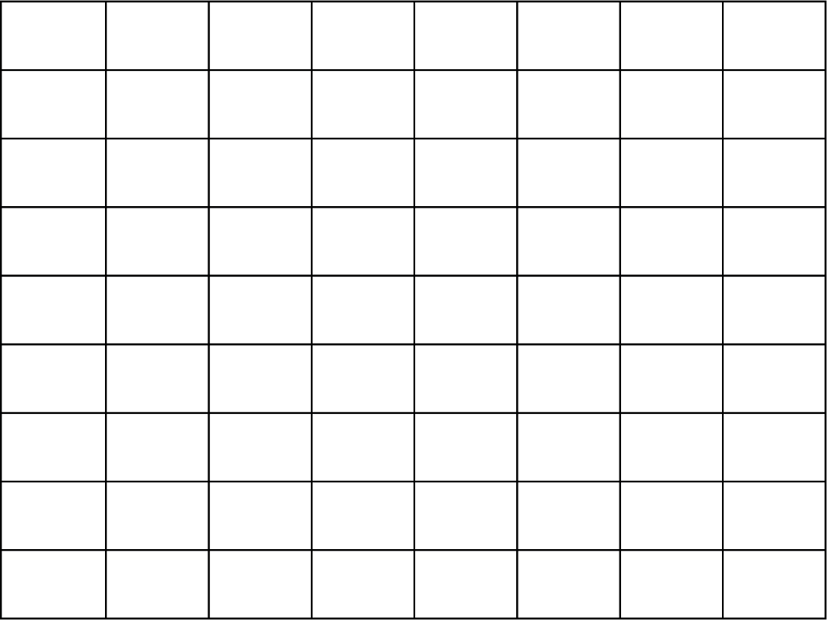
- A statistics teacher was interested in the connection between the time each week that a student spends studying and their final grade in the class. The teacher selected a random sample of 10 statistics students and recorded their weekly study time (in hours) and their final grade (as a percentage). The table below shows the collected data.
Create a scatter plot for the sample data in this scenario. Use study time as the independent variable x and final grade as the dependent variable y. Make sure you include proper axis labels and scales.

Frequency Distributions

What is a frequency distribution?

How can a frequency distribution be helpful in describing our data?

 Practice

Class | Lower Limit | Upper Limit | Frequency
1 | 65 | 70
2 | 71 | 76
3 | 77 | 82
- The heights of 10 randomly selected high school basketball players are shown below.
71 76 71 74 70 65 78 75 66 82
Complete the following frequency distribution table for this data.
What does this frequency distribution tell you about the heights of high school basketball players?

Histograms

What is a histogram?

Steps to Create a Histogram

Explain how to complete each of the steps listed below.

Steps
Step 1: Find the range of the data.
Step 2: Find the number of classes to use.
Step 3: Find the class width.
Step 4: Find the lower class limits.
Step 5: Find the upper class limits.
Step 6: Find the frequency for each class.
Step 7: Setup the $x$– and $y$–axis.
Step 8: Add the frequency bars for each class.
Explanation

Practice

Class | Lower Limit | Upper Limit | Frequency
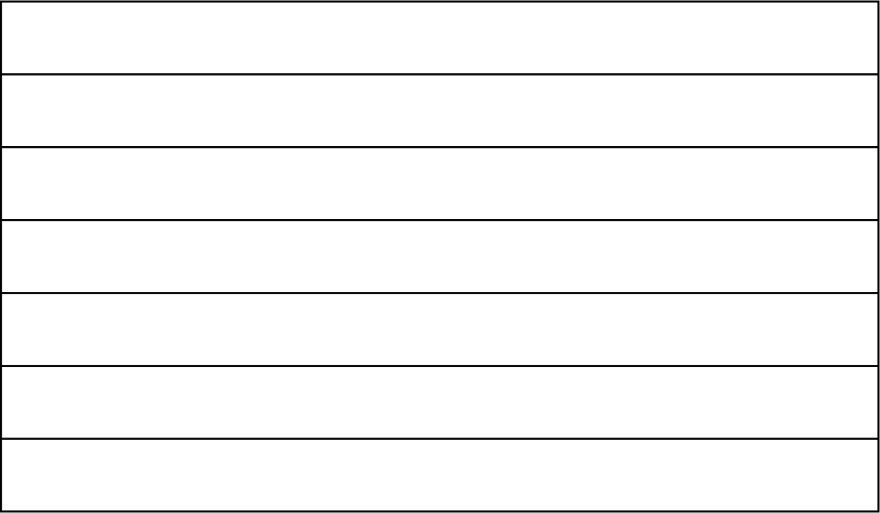
- The minimum play time (in minutes) of 10 randomly selected board games developed in 2021 are shown below.
50 15 15 90 30 45 40 30 20 60
Create a histogram for this set of data.
Step 1:
Step 2:
Step 3:
Step 4:
Step 5:
Step 6:
Step 7 & 8:
What does the histogram tell you about the minimum play time of 2021 board games?

Stem and Leaf Plot

What is a stem–and–leaf plot?

What are some guidelines for creating a good stem–and–leaf plot?

Practice

- The heights of 10 randomly selected high school basketball players are shown below.
71 76 71 74 70 65 78 75 66 82
Create a stem–and–leaf plot for this set of data.

4.3 – Beginning to Analyze Data

Measures of Center

Definition
Mean

Definition
Median

Definition
Mode

 Practice

- A statistics teacher was interested in analyzing the final grades of students in his class. The teacher selected a random sample of 12 statistics students and recorded their final grade (as a percentage). The final grades for each selected student are: 50 69 65 78 94 70 62 82 61 68 70 94.
Find the values of each measure of center.
  - Mean:
  - Median:
  - Mode:

Weighted Averages and Grades

What is a weighted average?

How do you find an overall course grade when the course uses weighted categories?

Practice

 | Homework | Projects | Exams
 | 75 | 80 | 70
 | 88 | 90 | 76
 | 98 | 88 | 82
 | 80
 | 100
Category Average:
- A teacher is using the following category weights when computing the final overall scores for students in her class: Homework (20%), Projects (40%), Exams (40%)
The table below shows the scores earned by one student in this class.
Calculate the final overall score for this student in the class.

Standard Deviation

Definition
Standard Deviation

Steps to Find the Sample Standard Deviation (Using Formula)

Step 1: Find the deviation ($x-\overline{x}$) for each data value.
Step 2: Square each deviation.
Step 3: Add all of the squared deviations together.
Step 4: Divide the sum of the squared deviations by $(n-1)$.
Step 5: Find the square root of the result from Step 4.

Steps to Find the Standard Deviation (Using TI–84/TI–83)

Step 1: Enter the data into a list (Stat –> Edit).
Step 2: Stat –> Calc –> 1:1–Var Stats
$s_{x}$ is the sample standard deviation.
$σ_{x}$ is the population standard deviation.

Steps to Find the Standard Deviation (Using Excel)

Step 1: Enter the data into a blank spreadsheet.
Step 2: Use the function STDEV.S to calculate the sample standard deviation. Use the function STDEV.P to calculate the population standard deviation.

Practice

- A statistics teacher was interested in analyzing the final grades of students in his class. The teacher selected a random sample of 12 statistics students and recorded their final grade (as a percentage). The final grades for each selected student are: 50 69 65 78 94 70 62 82 61 68 70 94.
Find the standard deviation for the sample data.
Standard Deviation:

68–95–99.7 Rule (aka Empirical Rule)

What is the Empirical Rule?

In each of the normal distribution curves below, fill in the missing percentages based on the Empirical Rule.

$$μ-3σ$$
$$μ-2σ$$
$$μ-σ$$
$$μ$$
$$μ+σ$$
$$μ+2σ$$
$$μ+3σ$$

$$μ-3σ$$
$$μ-2σ$$
$$μ-σ$$
$$μ$$
$$μ+σ$$
$$μ+2σ$$
$$μ+3σ$$

$$μ-3σ$$
$$μ-2σ$$
$$μ-σ$$
$$μ$$
$$μ+σ$$
$$μ+2σ$$
$$μ+3σ$$

Practice

- The weight of adult male orangutans is normally distributed with a mean of 191 pounds and a standard deviation of 8 pounds.
Use the Empirical Rule to approximate each of the following percentages.
  - What percentage of adult male orangutans would have a weight between 167 and 215 pounds?
  - What percentage of adult male orangutans would have a weight between 183 and 199 pounds?
  - What percentage of adult male orangutans would have a weight between 175 and 207 pounds?
  - What percentage of adult male orangutans would have a weight between 191 and 207 pounds?
  - What percentage of adult male orangutans would have a weight between 183 and 191 pounds?
  - What percentage of adult male orangutans would have a weight between 167 and 191 pounds?
  - What percentage of adult male orangutans would have a weight less than 167 pounds?
  - What percentage of adult male orangutans would have a weight greater than 199 pounds?
  - What percentage of adult male orangutans would have a weight greater than 207 pounds?

4.4 – Linear Regression

Linear Correlation

How can a scatterplot be used to determine the strength and direction of the linear correlation between two variables?

How can the correlation coefficient $r$ be used to determine the strength and direction of the linear correlation between two variables?

What is the strength of the correlation that is indicated be the $r$ values in each interval shown on the number line below?

-1
-0.7
-0.3
0
0.3
0.7
1

Practice

- Using each scatterplot below with its corresponding correlation coefficient, determine the strength (weak, moderate, or strong) and direction (positive or negative) of the correlation between the two variables.
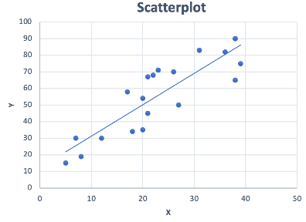
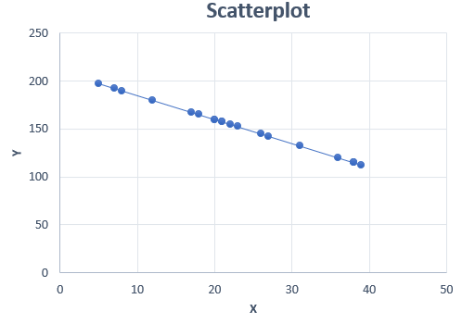
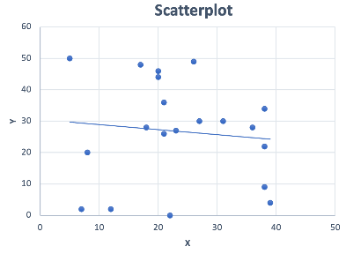
$$r=0.876$$
Strength:
Direction:

Direction: Positive
$$r=-1$$
Strength:
Direction:

Direction: Negative
$$r=-0.105$$
Strength:
Direction:

Direction: Negative

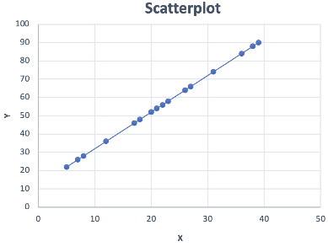
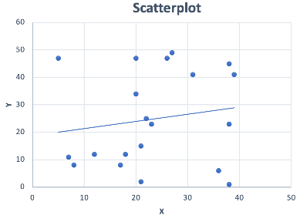
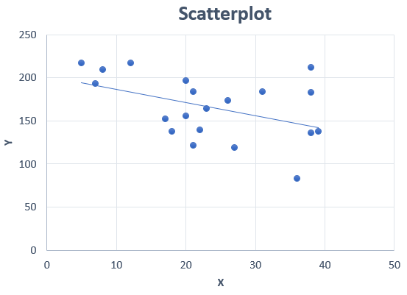
$$r=1$$
Strength:
Direction:

Direction: Positive
$$r=0.163$$
Strength:
Direction:

Direction: Positive
$$r=-0.444$$
Strength:
Direction:

Direction: Negative

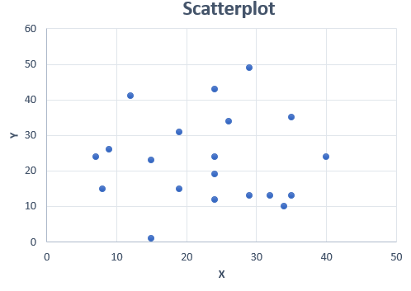
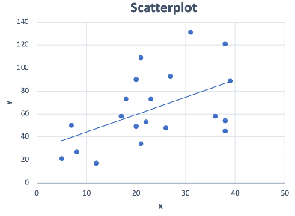
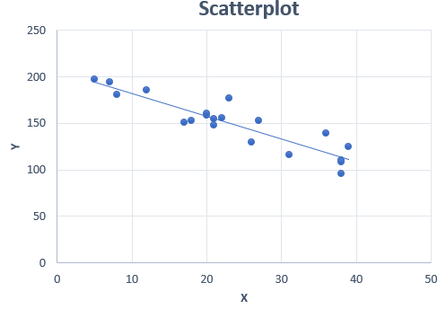
$$r=0$$
Strength:
Direction:

Direction: N/A
$$r=0.509$$
Strength:
Direction:

Direction: Positive
$$r=-0.911$$
Strength:
Direction:
Direction: Negative

Steps to Find r (Using TI–84/TI–83)

Step 1: Enter data into the calculator (Stat –> Edit).
Enter data for the independent $x$ variable into L1.
Enter data for the dependent $y$ variable into L2.
Step 2: Turn on Stat Diagnostics (so that you will see $r$ on the results screen).
TI–84: Mode –> Stat Diagnostics –> On
TI–83: 2nd 0 –> DiagnosticsOn
Step 3: Run the linear regression.
TI–84: Stat –> Calc –> 4:LinReg(ax+b),Xlist:L1, Ylist:L2
TI–83: Stat –> Calc –> 4:LinReg(ax+b) L1, L2

Steps to Find r (Using Excel)

Step 1: Enter data into a blank spreadsheet.
Enter data for the independent $x$ variable into column 1.
Enter data for the dependent $y$ variable into column 2.

Step 2: Use the function CORREL to calculate $r$.

Practice

Min Play Time ($x$) | 50 | 45 | 45 | 7.5 | 10 | 30 | 110 | 30 | 20 | 5
Rating ($y$) | 7.9 | 7.9 | 8.1 | 8.7 | 9.6 | 8 | 7 | 8.2 | 8.6 | 9
- Connor wants to determine if the minimum play time for board games is related to the satisfaction rating of players. He collects a random sample of 10 board games released in 2021 and records the minimum play time (in minutes) and average satisfaction rating (scale from 0–10, 0: not satisfied, 10: very satisfied). The data appears in the table below.
What is the correlation coefficient $r$ for the board game data?
Based on $r$, what is the strength and direction of the correlation between the minimum play time and the satisfaction rating for board games in 2021?
Strength:
Direction:

Line of Best Fit

Definition
Line of Best Fit

Steps to Approximate the Line of Best Fit Using Two Points

Step 1: Create a scatterplot for your data.
Step 2: Use your scatterplot to select two data points that appear to be closest to where the line of best fit would likely be.
Step 3: Calculate the slope ($m$) and y–intercept ($b$) for the line containing the two selected data points.
Step 4: Write the slope–intercept equation using the slope and y–intercept.
$y=mx+b$
Prediction: If there is a strong correlation between the variables (based on your scatterplot and $r$), you may use your equation to predict values of $y$ for a given value of $x$. Make sure the $x$ value used is within the scope of the original data.

Steps to Find the Line of Best Fit (Using TI–84/TI–83)

Step 1: Enter data into the calculator (Stat –> Edit).
Enter data for the independent $x$ variable into L1.
Enter data for the dependent $y$ variable into L2.
Step 2: Run the linear regression.
TI–84: Stat –> Calc –> 4:LinReg(ax+b),Xlist:L1, Ylist:L2
TI–83: Stat –> Calc –> 4:LinReg(ax+b) L1, L2

Steps to Find the Line of Best Fit (Using Excel)

Step 1: Enter data into a blank spreadsheet.
Enter data for the independent $x$ variable into column 1.
Enter data for the dependent $y$ variable into column 2.

Step 2: Create a scatterplot.
Select your data.
Click Insert –> Chart –> X Y (Scatter).
Click OK.
Click Add Chart Element –> Trendline –> More Trendline Options.
Select “Linear”.
Check Display Equation on chart.

Practice

Min Play Time ($x$) | 50 | 45 | 45 | 7.5 | 10 | 30 | 110 | 30 | 20 | 5
Rating ($y$) | 7.9 | 7.9 | 8.1 | 8.7 | 9.6 | 8 | 7 | 8.2 | 8.6 | 9
- Connor wants to determine if the minimum play time for board games is related to the satisfaction rating of players. He collects a random sample of 10 board games released in 2021 and records the minimum play time (in minutes) and average satisfaction rating (scale from 0–10, 0: not satisfied, 10: very satisfied). The data appears in the table below.
What is the equation for the line of best fit?
Is it appropriate to use your line-of-best-fit equation for prediction? Explain.
Using your line-of-best-fit equation, what satisfaction rating would you predict for a board game with a minimum play time of 80 minutes?

Unit 5 – Exponential and Quadratic Equations

5.1 – Functions

Identifying Functions

Definition
Function

What are some examples of relations that are functions?
What are some examples of relations that are not functions?

Vertical Line Test

You can identify a function by using the vertical line test. If it is a function, you can draw a vertical line anywhere on the graph and it will only pass through the function at one point.

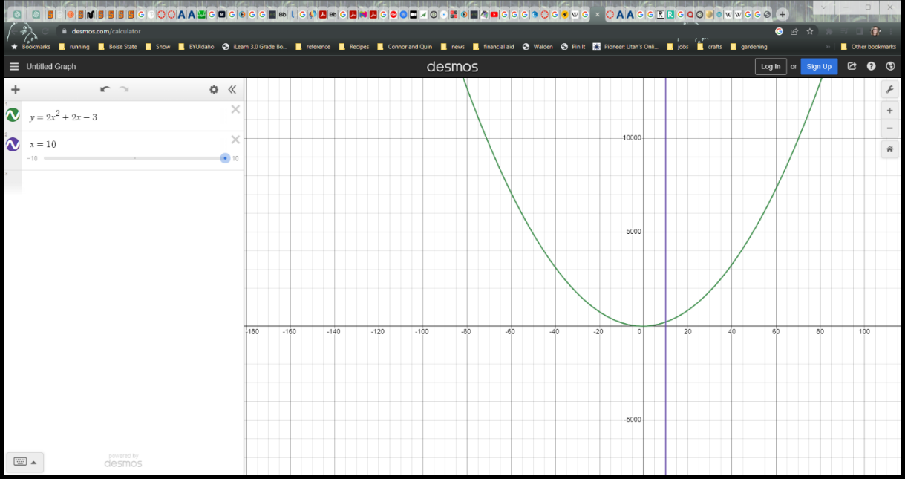
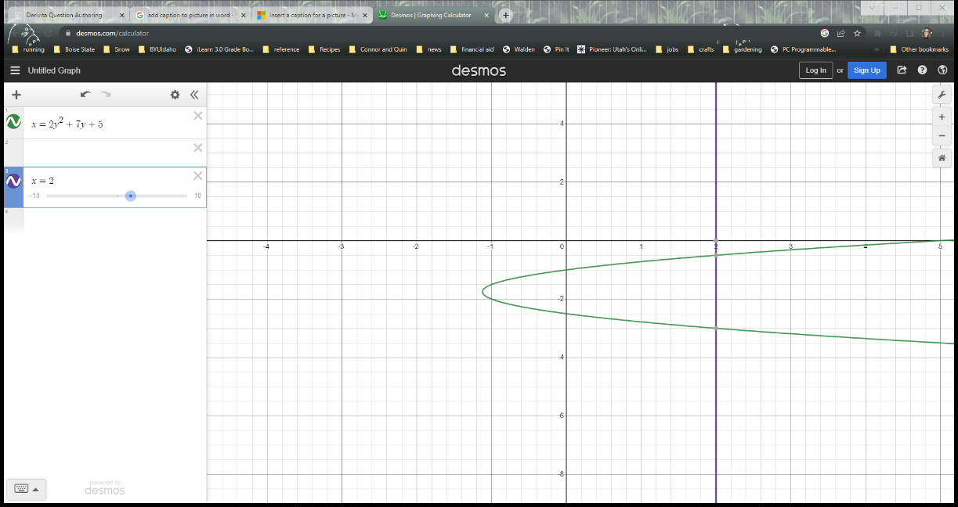
Figure 1 This passes the vertical line test. Therefore, it is a function.
Figure 2 This does not pass the vertical line test because the vertical line passes through the graph of the equation at two points. This is not a function.

Practice

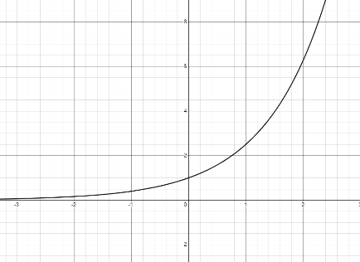
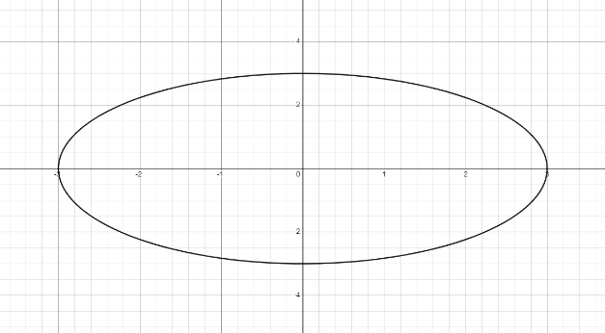
- Identify whether each of the following graphs or tables represents a function or not.
$y={2.5}^{x}$
$9=y^{2}+x^{2}$
x | Y
2 | 15
4 | 30
6 | 45
8 | 60
Table 1
x | Y
4 | 2
4 | –2
9 | 3
9 | –3
16 | 4
Table 2

Function Notation

Function notation gives us an easy way to represent functions. In the function $f\left(x\right)=5x-2$, f(x) is the output of the function named f, and x is the input. f(x) would be read as “f of x” and does not indicate multiplication.

Practice

- Evaluate each function for the given value.
- $f\left(x\right)=-2x+9$ $f\left(8\right)=$
- $f\left(x\right)=3x^{2}-2x+1$ $f\left(2\right)=$
- $g\left(t\right)=500{\left(1.07\right)}^{t}$ $g\left(5\right)=$

5.2 – Algebraic Expressions

Addition and Subtraction of Algebraic Expressions

Definition
Like Terms

What are some examples of like terms?

What are some examples of terms that are not like terms?

Steps for Adding or Subtracting Algebraic Expressions

Step 1: Distribute (including + or – signs).

Step 2: Identify like terms.
Step 3: Group like terms.
Step 4: Combine like terms.

Practice

Simplify each expression completely.

- $\left(5x^{2}-3x+8\right)-\left(3x^{2}+2x-4\right)$
- $\left(4x^{5}+2x^{3}-7x\right)+\left(6x^{5}-3x^{4}+2x^{3}\right)$
- $\left(7x^{3}-3x+1\right)-\left(x^{3}+2x-5\right)$
- $2\left(x^{2}+3\right)-4\left({2x}^{2}-1\right)$
- $4x^{4}-3x^{2}+2x^{3}+x^{4}-x+5x^{3}-8$

Multiplication of Algebraic Expressions

When multiplying algebraic expressions, we will need to use the distributive property.

Definition
Distributive Property

Explain how to multiply for following expression using the distributive property.
$$6\left(2x-3\right)$$

Explain how to multiply for following expression using the distributive property.
$$(2x-4)(3x+5)$$

Practice

Use the distributive property to multiply each of the following expressions.
- $2x\left(7x^{2}+4\right)$
- $\left(7x+2\right)\left(9x+3\right)$
- $\left(6x^{2}–5x\right)\left(2x–5\right)$
- $\left(2x–1\right)\left(6x^{2}–8x+9\right)$
- $(2x^{2}+2x–5)(3x^{2}–5x–9)$

Revenue, Cost, and Profit

Now that you’ve learned to add, subtract, and multiply algebraic expressions, what applications can you think of where you might need to perform these operations?

One application involves revenue, cost, and profit.

Definition
Revenue

Definition
Cost

Definition
Profit

Consider the following scenario:

You own a dessert shop where you sell cookies, pies, donuts, and ice cream. Your most popular cookie, the giant chocolate chunk snickerdoodle, regularly sells for $3.50 each. At this price, you find that you can sell about 400 of the cookies each week. When you discounted the cookies to $3.00 each for your midsummer sale, you sold 525 cookies a week. You want to figure out the optimal price to sell your cookies at to maximize your profit.

Steps for Maximizing Profit

- Create a formula relating price to the number of items sold.
- Create a formula relating revenue to the number of items sold.
- Create a formula relating cost to the number of items sold.
- Create a formula relating profit to the number of items sold.
- Find the maximum of the profit formula.
- Plug the maximum into the price formula to find the optimal price.

 Step 1 – Create a formula relating price to number of items sold.

We’re going to assume that the relationship between the price and the number of items sold is linear, with x (our independent variable) representing the number of cookies sold each week, and y (our dependent variable) representing the price the cookies are sold at. In this case, our price is going to be determined by the number of cookies that we want to sell in a week.

Remember that we sold 400 cookies a week at a price of $3.50 and 525 cookies a week at a price of $3.00. For a reminder of how to write linear equations, review Unit 3.

Price Formula

Steps
- Find the slope using the information given and the slope formula.
- Use the slope and the information given to find the y–intercept.
- Write the formula using the slope and y–intercept you found.
Written Work

Step 2 – Create a formula relating revenue to number of items sold.

Revenue Formula

Steps
- Multiply the price formula by x.

Written Work

Step 3 – Create a formula relating total cost to number of items sold.

Each cookie costs you $1.25 to make and the portion of your weekly fixed costs that are attributable to the cookies is $175.

Cost Formula

Steps
- The cost formula will be linear with the variable costs as the slope and the fixed costs as the y–intercept.
Written Work

Step 4 – Create a formula relating profit to the number of items sold.

Profit Formula

Steps
- Subtract the cost formula from the revenue formula.

Written Work

Step 5 – Find the maximum of the profit formula.

Since we haven’t yet learned how to find the maximum of a quadratic equation, we will find this point by using the graph in Desmos.
Based on the Desmos graph, what is the maximum of the profit formula?

What does this point tell us about our dessert business and our cookies?

Step 6 – Plug the maximum into the price formula.

The maximum of our profit formula told us that we want to sell about 481 cookies to maximize our profit. If we plug this value into our price formula, we can find out what price we should sell our cookies at to reach this maximum profit.
At what price should we sell our cookies?

Practice

- As the owner of a pet supply store, you are trying to maximize your profits. You sell a popular catnip mouse toy for $4.00. At this price, you can sell 150 of the toys per month. Because of inflation, you decide to raise your price to $4.25, but at this price point you only sell 100 of the toys per month. You get the toys for a wholesale price of $2.85 and your fixed monthly costs associated with the toys is $75. What price should you sell the catnip toys at in order to maximize your profits?
Step 1 – Create a formula relating price to number of items sold.
Step 2 – Create a formula relating revenue to number of items sold.
Step 3 – Create a formula relating total cost to number of items sold.
Step 4 – Create a formula relating profit to number of items sold.
Step 5 – Find the maximum of the profit formula.
What does this tell us about the catnip toys you sell in your shop?
Step 6 – Plug the maximum into the price formula.
What price should you sell the catnip toys at in order to maximize your profits?

5.3 – Quadratic Functions

Quadratic Graphs and Applications

Definition
Parabola

Definition
Symmetry

The function that describes the profit of a bike tire manufacturer is
$f\left(x\right)=-0.005x^{2}+7x-500$, which is a quadratic function.

Definition
Quadratic Function

What are some examples of quadratic functions?

What are some examples of functions that are not quadratic?

Practice

Which of the following are quadratic functions?
- $f\left(x\right)=2x^{2}-1$
- $g\left(x\right)=7x+9x^{2}$
- $h\left(x\right)=x^{2}+5$
- $f\left(x\right)=5\sqrt{x}+2x^{2}$
- $g\left(x\right)=3x\left(x-1\right)+5$
- $h\left(x\right)=x^{2}\left(x+4\right)$
- You have decided to build a “catio” (cat run) for your three cats. After thoroughly researching your options, you decide you can afford the materials for a rectangular cat run that has a perimeter of 100 ft and you want to maximize the area so that your cats have plenty of room to roam and play. Determine what length and width you should make the catio to maximize the area of the cat run.
What would the length of the cat run need to be if you made the width 10 feet?
What would the length of the cat run need to be if you made the width 5 feet?
Width (ft.) | Length (ft.) | Area (ft²)
1
5
10
15
20
25
30
35
40
45
50
Fill out the table below and plot the points on the graph with the width on the $x$ axis and the area on the $y$ axis. Remember that the area of a rectangle is calculated by multiplying the length by the width and perimeter is calculated by adding the lengths of all the sides.
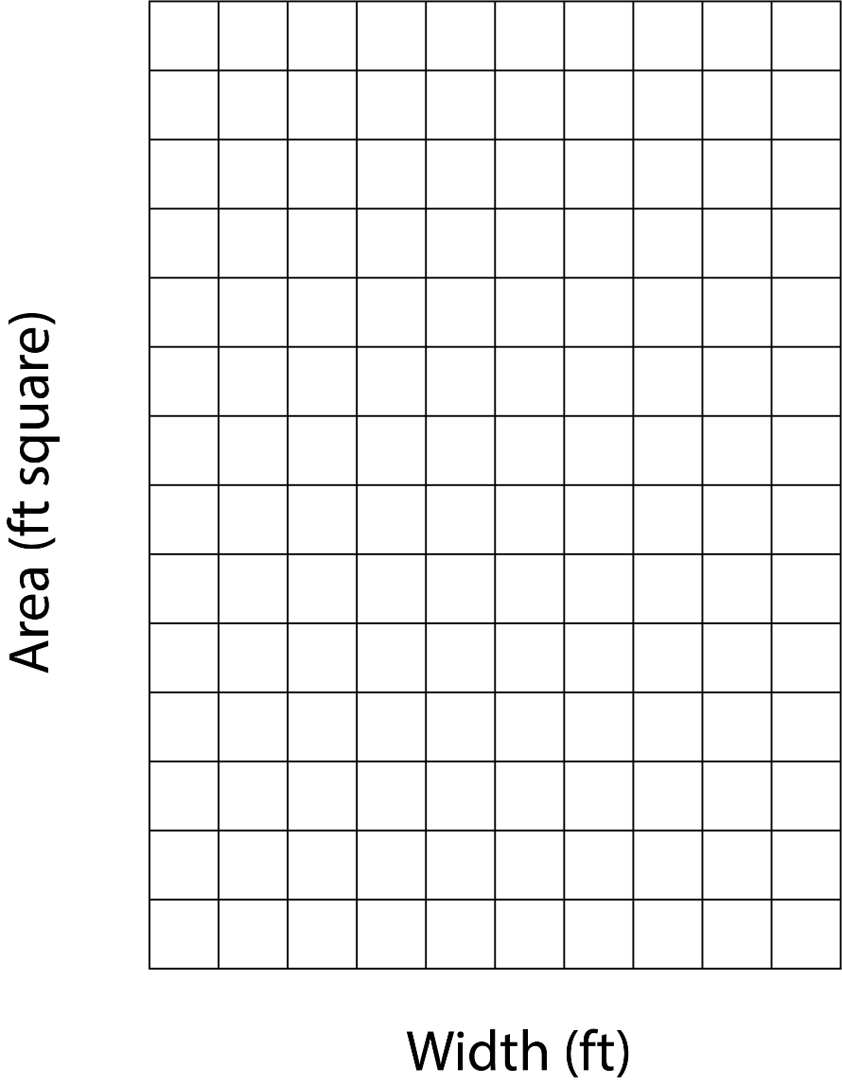
Area (ft²)

Based on the graph, what width gives the largest area for the catio and what is that area?
What is the shape of the catio that gives the largest area?
What was the process for finding the length for each given width?
For a width of w and a perimeter of P, write a generalized formula for this process.
Substitute this formula into the area formula to find a generalized formula for finding the area from a given width and perimeter. Simplify your formula fully.

- The graph below shows the profit a company makes from manufacturing bike tires. Use the graph to make estimates and answer the following questions.
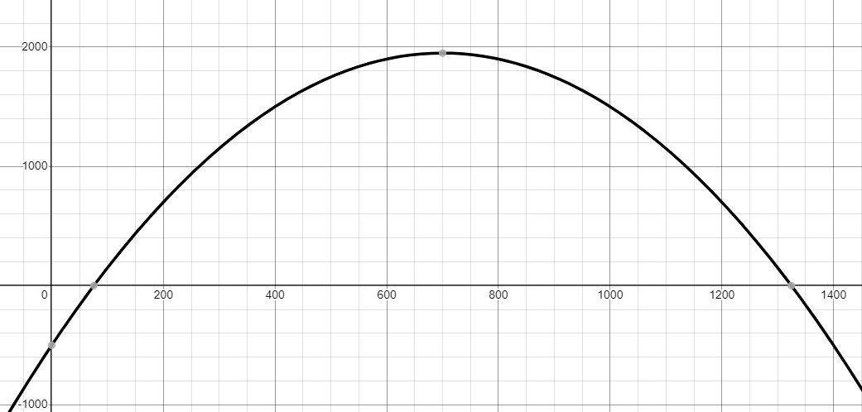
What is the y–intercept and what does it tell us about the bike tire manufacturer?
Profit
# of Tires
What are the x–intercepts and what do they tell us about the bike tire manufacturer?
What is the maximum profit this company can earn from manufacturing bike tires?
How many bike tires do they need to manufacture to reach the maximum profit?
Why do you think the company would make less money from making 900 bike tires than from making 700 bike tires?

Factoring to Find Zeroes

Definition
Factor

Definition
Zero of a Function

Factoring – Leading Coefficient is 1: $x^{2}+7x+10$

Steps
- Find the factor pairs of the constant.
- Add each factor pair to determine which factor pairs add to equal the middle term coefficient.
- Write in factored form using the factors found in step 2.
Written Work

Factoring – Leading Coefficient ≠ 1 (Synthetic Factoring): $2x^{2}+11x+12$

Steps
- Factor out the greatest common factor if there is one.
- Multiply the leading coefficient by the constant.
- Find the factor pairs of the number found in step 1.
- Add each factor pair to determine which factor pair adds to equal the middle term coefficient.
- Write each number in the fact
or pair as a fraction over the leading coefficient.
- Simplify each fraction if possible. Write whole numbers as fractions over 1.
- Write the expression in factored form using the denominators of the fractions as the coefficients in front of the variable and the numerators as the constants.
Written Work

Factoring – Leading Coefficient ≠ 1 (Grouping): $2x^{2}+11x+12$

Steps
- Factor out the greatest common factor if there is one.
- Multiply the leading coefficient by the constant.
- Find the factor pairs of the number found in step 1.
- Add each factor pair to determine which factor pair adds to equal the middle term coefficient.
- Rewrite the expression, splitting the middle term into the factors found in step 3.
- Group the first two terms and the last two terms, then factor out the greatest common factor from each grouping.
- Factor out the common factor from each term to get the final factored form.
Written Work

Practice

- You are playing catch with your dog, throwing a tennis ball for your dog to catch and bring back to you. The function $h\left(t\right)=-16t^{2}+20t+6$ models the height h (in feet) of the tennis ball at time t (in seconds). How long does your dog have to catch the tennis ball before it hits the ground?
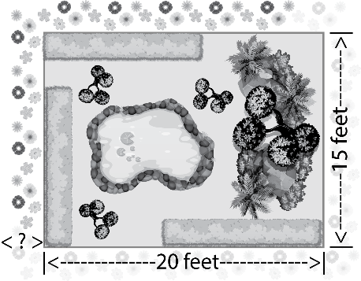
- You have a rectangular garden that is 15 ft by 20 ft. You would like to plant a border of wildflowers around the edge of the garden. You have enough wildflower seeds to cover a 74 ft² area and you want the border to be an even width all the way around the garden. How wide should the border be?

Quadratic Formula to Find Zeros

Some functions are not factorable. We call these functions “prime” functions. When a function isn’t factorable, we need another method to find the zeros of the function. In this case we will use the Quadratic Formula.

Formula
Quadratic Formula

Find the Zeros Using the Quadratic Formula: $2x^{2}-8x+5=0$

Steps
- Make sure the equation is in the form $ax^{2}+bx+c=0$. Solve for 0 if needed.
- Put the coefficients into the quadratic formula.
- Simplify. Be sure to follow the Order of Operations.
Written Work

Practice

- Let’s revisit our dessert shop. We found the following equation to represent the profit from selling our gourmet cookies: P = –0.004x² + 3.85x – 175.
Use the quadratic formula to find the zeros of this function.
What do these zeros tell us about our dessert shop and the profit made from selling the cookies?
How is it possible that our profit is zero after selling so many cookies?

- The function $f\left(x\right)=-0.03001x^{2}+x+5.8$ can be used to model a shot–put throw, where x represents the horizontal distance in feet of the shotput and y represents the height of the shotput in feet. How long was the throw?

Vertex of Quadratic Functions

Definition & Formula
Vertex

Practice

- Let’s revisit our dessert shop one more time. Previously, we found the maximum profit using Desmos. Now we can find the maximum profit using the vertex formula.
  - Using the profit formula we previously found, P = –0.004x² + 3.85x – 175, use the vertex formula to find the number of cookies it takes to reach the maximum profit.
  - Use the vertex formula to find the maximum profit.

5.4 – Exponential Models

Compound Interest

Definition
Exponential Function

Definition
Compound Interest

Formula
Compound Interest

Practice

- While shopping for a new tv, a very persuasive salesperson talked you into buying a larger and more expensive tv than you had originally planned on buying. And not only that, but they also convinced you to sign up for a nothing down, no payments due for the first 5 years, financing plan for the tv.
What you failed to realize until after you had signed all the paperwork was that during those first five years, the loan would be accumulating 12% interest, compounded yearly. If the original price of the tv was $800, how much will you owe on the tv when you start making payments in 5 years?
 | Interest Accumulated  Per Year | Loan Balance After…
Start | $0 | $800
Year 1
Year 2
Year 3
Year 4
Year 5

- Your grandma gave you a surprise 21st birthday gift of $1500, and instead of going out and spending all of it, you decide to put the money in to a CD (certificate of deposit) savings account for 5 years. The best interest rate for a 5–year CD that you can find is 4.10%. How much money will you have in the account in 5 years?

Other Exponential Growth

What are some tips and strategies to use when solving application or word problems involving exponential growth?

Practice

- Your roommate has developed a new app and published it to Google Play and the Apple app store. On the first day it was published, you were the only one to download the app (just to be nice to your roommate). On the second day, two people had downloaded the app (your other roommate has now downloaded the app as well). Each day, the number of people that have downloaded the app doubles. This means by day 3, four people have downloaded the app, by day 4, eight people have downloaded the app and so forth.
If this pattern continues, how many people will have downloaded the app by the end of the week?
How many people will have downloaded the app by the end of the month (assuming a month length of 30 days)?

- You accidentally leave a loaf of bread in your pantry for too long without eating it. The next time you decide to make a sandwich, you notice a 1 cm² patch of mold on the bread. You decide to cook some eggs instead of eating a sandwich but forget to throw the loaf of bread away. You find the loaf of bread again the next day and notice that the patch of mold is about 25% bigger than it was the day before. If the patch of mold continues to grow by 25% each day, how large will the patch of mold be after 9 days when you finally remember to throw away the loaf of bread?

Exponential Decay

What are some tips and strategies to use when solving application or word problems involving exponential decay?

Practice

- You have a fun date planned for the same day as your dentist appointment. Your dentist appointment is at 2 pm and the dentist uses 2.5 milliliters of a 2% lidocaine solution to numb your tooth before working on it. Lidocaine is metabolized at a rate of about 30% per hour. Will your mouth still be numb when your date starts at 6pm? Assume that you stop feeling the effects of the lidocaine when the level drops below 0.5 milliliters.

- You bought a used car for $8000 when you first started college and you’ve been careful to maintain the car so that it continues to run well. You are hoping to sell the car in a few years, after you’ve completed your graduate degree and secured a job. You know that this make and model of car depreciates at a rate of about 15% per year as long as it is well maintained. How much do you expect the car to be worth in 6 years?

Comparing Exponential and Linear Growth

What are the similarities and differences between exponential and linear growth?
How can you tell if a given scenario involves exponential or linear growth?

Practice

- You have $1000 dollars that you decide to split evenly between two accounts. Account 1 has 4% simple interest and account 2 has 4% compound interest.
 | Account 1 | Account 2
Start | $500 | $500
After 1 year
After 2 years
After 3 years
After 4 years
After 5 years
After 6 years
  - Fill out the table below for each account.
  - Subtract the starting value of account 1 from the value after 1 year. What is the result?
  - Subtract the value of account 1 after 1 year from the value after 2 years. What is the result?
  - Do the same for each of the following consecutive years for account 1. What is the result of each of these subtractions?
  - What happens when you do this same kind of subtraction for account 2?
  - Divide the value of account 2 after 1 year by the value of the account at the start. What is the result?
  - Divide the value of account 2 after 2 years by the value of the account after 1 year. What is the result?
  - Continue dividing the value of the account 2 for each year by the previous year’s value. What is the result for each of these divisions?
  - Perform the same division for each of the years’ values for account 1. What is the result?
  - What do these results tell you about the difference between simple interest (linear growth) and compound interest (exponential growth)?

 | Account 1 |  | Account 2
Start | $800 | Start | $1000
After 1 Year | $824 | After 1 Year | $1060
After 2 Years | $848.72 | After 2 Years | $1120
After 3 Years | $874.18 | After 3 Years | $1180
After 4 Years | $900.41 | After 4 Years | $1240
After 5 Years | $927.42 | After 5 Years | $1300
After 6 Years | $955.24 | After 6 Years | $1360
- The table below shows the value of two different savings accounts for the first 6 years. One savings account has simple interest and the other has compound interest.
  - Which savings account has simple interest, and which has compound interest?
  - How much is each account growing by each year?
  - What would the value of each account be after 7 years?

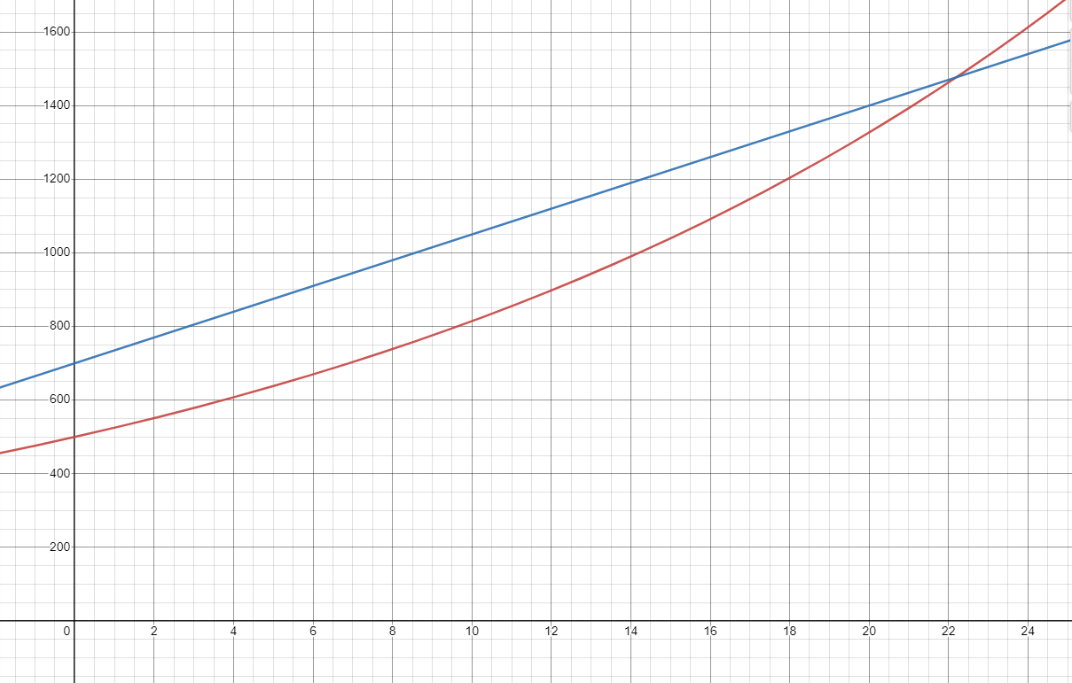
- The graph below shows the growth of two different savings accounts. One account starts with $500 and grows by 5% compound interest each year. The second account starts with $700 and grows by 5% simple interest.
Account 1
Account 2
  - Based on the graph, which account has simple interest, and which has compound interest?
  - At what point is account 1 worth more than account 2?
  - Which account would you rather have?

5.5 – Exponential Regression

What are some tips and strategies to use when solving application or word problems involving exponential regression?

Practice

In this exponential decay experiment, you are going to model exponential decay using M&Ms.
- Count the number of M&Ms in your cup. Enter this amount for Trial 0 on the table below.
- Place all the M&Ms back in the cup and shake them out onto the table. Remove any M&Ms with the M face-up. (You can eat them if you want!) Count the number of remaining M&Ms and record this number for Trial 1 on the table below.
- Continue the process outlined above for the rest of the trials on the table, each time removing any M&Ms that land with the M face-up and counting the remaining M&Ms to record on the table. Stop when the table is complete, or the number of M&Ms remaining is less than 2. (Don’t record the value if you have zero M&Ms remaining.)
Trial # | M&Ms Remaining
0
1
2
3
4
5
6
7
8
9
10

- Make a scatterplot from your table using a graphing calculator or Excel.

- Find the exponential equation of best fit (trendline) for the graph. If you are using Excel, convert your equation from the form $y=ae^{kx}$ to the form $y=ab^{x}$ by finding ${b=2.8}^{k}$.
- In your equation in the form $y=ab^{x}$, what is the value of a and what does it tell us about our experiment? Does it match the data on your table?
- What is the value of b from your equation and what does it tell us about our experiment?
- What is the probability that a single M&M will land with the M face-up?
- Thinking about the probability in the previous question, with 200 M&Ms, how many would you expect to land face-up?
- How does this probability relate to the exponential equation that you found from the M&M experiment?

5.6 – Logarithms

Introduction to Logarithms

Suppose you put $1000 into a savings account with 5% interest compounded annually. How long will it take for the account to grow to a value of $15,000? We can model this with the exponential equation $y=1000{\left(1.05\right)}^{x}$ and plug 15,000 in for y. This gives us the equation $15000=1000{\left(1.05\right)}^{x}$. But how do we solve this equation? For this we need to use logarithms.

Definition
Logarithm

$y=b^{x}$is equivalent to$\log_{b}y=x$

Definition
Common Log

Definition
Natural Log

Practice

- Convert each of the following exponential equations into logarithmic form.
  - $2^{x}=15$
  - $8^{x}=47$
- Convert each of the following logarithmic equations into the equivalent exponential form.
  - $\log_{3}5=x$
  - $\log_{14}9=x$
- Evaluate each of the following logarithmic expressions. Round to the nearest thousandth.
  - $\log\left(1\right)=$
  - $\log\left(1000\right)=$
  - $\log\left(30\right)=$
  - $\ln\left(e\right)=$
  - $\ln\left(42\right)=$

Change of Base

Common logs and natural logs are found on your calculator, but how do we compute logs of other bases?

To change the base from base b to base c:

$$\log_{b}a=\frac{\log_{c}a}{\log_{c}b}$$

Practice

- Use the change of base formula and your calculator to find an approximate value for each of the logarithms below.
  - $\log_{2}6$
  - $\log_{7}13$

Applications

What are some tips and strategies to use when solving application or word problems involving logarithms?

Practice

- Now, back to the problem we started with: Suppose you put $1000 into a savings account with 5% interest compounded annually. How long will it take for the account to grow to a value of $15,000?

