Regular and Substantive Interaction (RSI) at Snow College
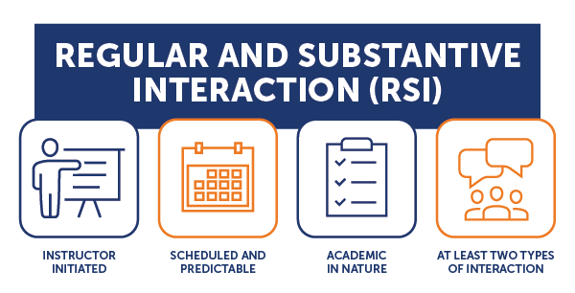

What Is RSI and Why Does It Matter?
Regular and Substantive Interaction (RSI) is a federal requirement that ensures meaningful engagement between instructors and students in online and broadcast courses. It distinguishes distance education (eligible for federal financial aid) from correspondence education (not eligible).

Pedagogical Benefits of RSI

1. Better Engagement
- Active participation increases when students interact regularly with instructors and peers.
- Interaction fosters a sense of community, combatting isolation.
- Studies show that discussion forums, video conferencing, and personalized feedback enhance student motivation and attention.

2. Higher Retention
- Students who feel connected and supported are more likely to stay enrolled.
- Regular interaction helps build academic and emotional investment.
- Institutions that prioritize instructor presence and timely communication report significantly improved retention metrics.

3. More Consistent Student Work
- Frequent feedback and check-ins promote accountability and time management.
- Students are more likely to submit assignments on time and maintain quality when they know their work is being monitored and discussed.
- Scaffolded learning through regular interaction helps students stay on track with course objectives.

4. Higher Success Rates
- Courses with high levels of instructor interaction show better student performance on assessments.
- Success is linked to clarity of expectations, timely support, and constructive feedback—all facilitated by substantive interaction.
- Peer-reviewed studies confirm that interactive online environments correlate with higher grades and completion rates.

5. More Connection with Professor and Peers
- Building relationships in online settings requires intentional interaction.
- Students report greater satisfaction when they feel seen and heard by instructors and classmates.
- This connection fosters collaboration, peer learning, and emotional support, which are critical for academic success.

6. Early Intervention and More Student Support
- Regular communication allows instructors to identify struggling students early.
- Early alerts and personalized outreach can address academic or personal challenges before they escalate.
- This proactive approach leads to better outcomes and more equitable support, especially for underserved populations.

Failure to Meet
Failure to meet RSI standards can result in:
- Loss of access to Title IV financial aid
- Financial penalties during audits or program reviews
- Reclassification of courses as correspondence education

Key Definitions
Instructor: A qualified individual responsible for delivering course content, as defined by the institution’s accrediting agency.
Distance Education: Instruction delivered via technology (e.g., internet, video conferencing) to students separated from the instructor, with scheduled and predictable opportunities for substantive interaction. Interaction is primarily initiated by the instructor.
Correspondence Course: A course provided by an institution under which the institution provides instructional materials, by mail or electronic transmission, including examinations on the materials, to students who are separated from the instructor. Interaction between the instructor and student is limited, is not regular and substantive, and is primarily initiated by the student. Correspondence courses are typically self-paced.

RSI Requirements
To comply with RSI, interactions must:
- Be initiated by the instructor
- Be scheduled and predictable
- Be academic in nature
- Include at least two of the following:

Substantive Interaction Activities | Examples
Direct Instruction | Live online lectures, synchronous sessions
Feedback on Coursework | Grading with comments, rubrics, revision guidance
Responding to Questions | Course Q&A forums, email replies
Group Discussions | Moderated discussion boards, breakout rooms, discussions in FeedbackFruits
Other Approved Activities | Peer review facilitation, guided reflections

Regular Interaction Must Be:
- Predictable: Occurs at set intervals (e.g., weekly check-ins, established virtual office hours)
- Scheduled: Clearly outlined in the syllabus and course calendar
- Responsive: Instructors must monitor student progress and proactively engage when needed

How to Implement RSI in Your Course
- Include an RSI statement in your syllabus (e.g., instructor expectations, student expectations)
- Participate in discussion forums
- Use engagement tools (e.g., FeedbackFruits) to engage with student learning
- Schedule virtual office hours or synchronous review sessions
- Provide timely feedback on assignments
- Monitor student engagement and intervene when necessary
- Post weekly announcements relating to the content or student submitted work and not just assignment due dates

What RSI looks like at Snow

Resources
- SUNY OSCQR RSI Page[1]

Contact Us
For support implementing RSI in your course, reach out to:
Teaching and Learning Center
Justin Thorpe
Director – Teaching and Learning Center
justin.thorpe@snow.edu
435-283-7340

