Puzzles

Name:___________________________ Period:______________

Find TWO solutions to each of the following.

- Connect the dots with the shortest possible line.
- Move one line segment to make a perfect square.
- What number is next in this sequence? 3 6 9 12 ______
1
2
3
- Complete the crossword.

DOWN
- Small coin
- Rubbed abrasively

ACROSS
- Canine
- Take a breather

Identify each picture.

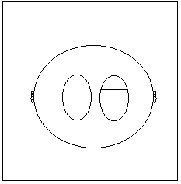
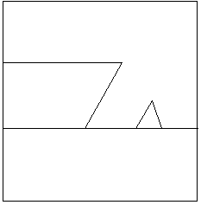
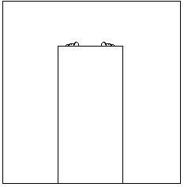
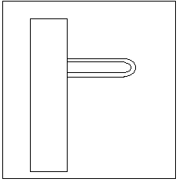
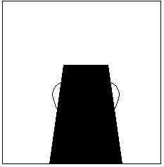
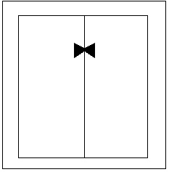

- Explain the meaning of this acronym: ETMOTA.
- What’s the opposite of “not in”?
- What unusual word of seven letters has three U’s in it?
- Was Romeo a Capulet or Montague?
- Are rock formations hanging from the ceiling called stalagmites or stalactites?

Match each Latin phrase with its direct translation.

- Bona fide ________
- Rara avis ________
- Sic transit ________
- Vice versa ________
- Id est ________
- Alter ego ________
- Vide supra ________
- A good rental car is hard to find
- See the janitor
- Freudian self-actualization
- Ambulance
- Change your psyche
- Good day
- Dirty poem

