Name___________________________ Class time: ____________ Score .

In 1-2, Determine whether each graph is the graph of a one-to-one function.

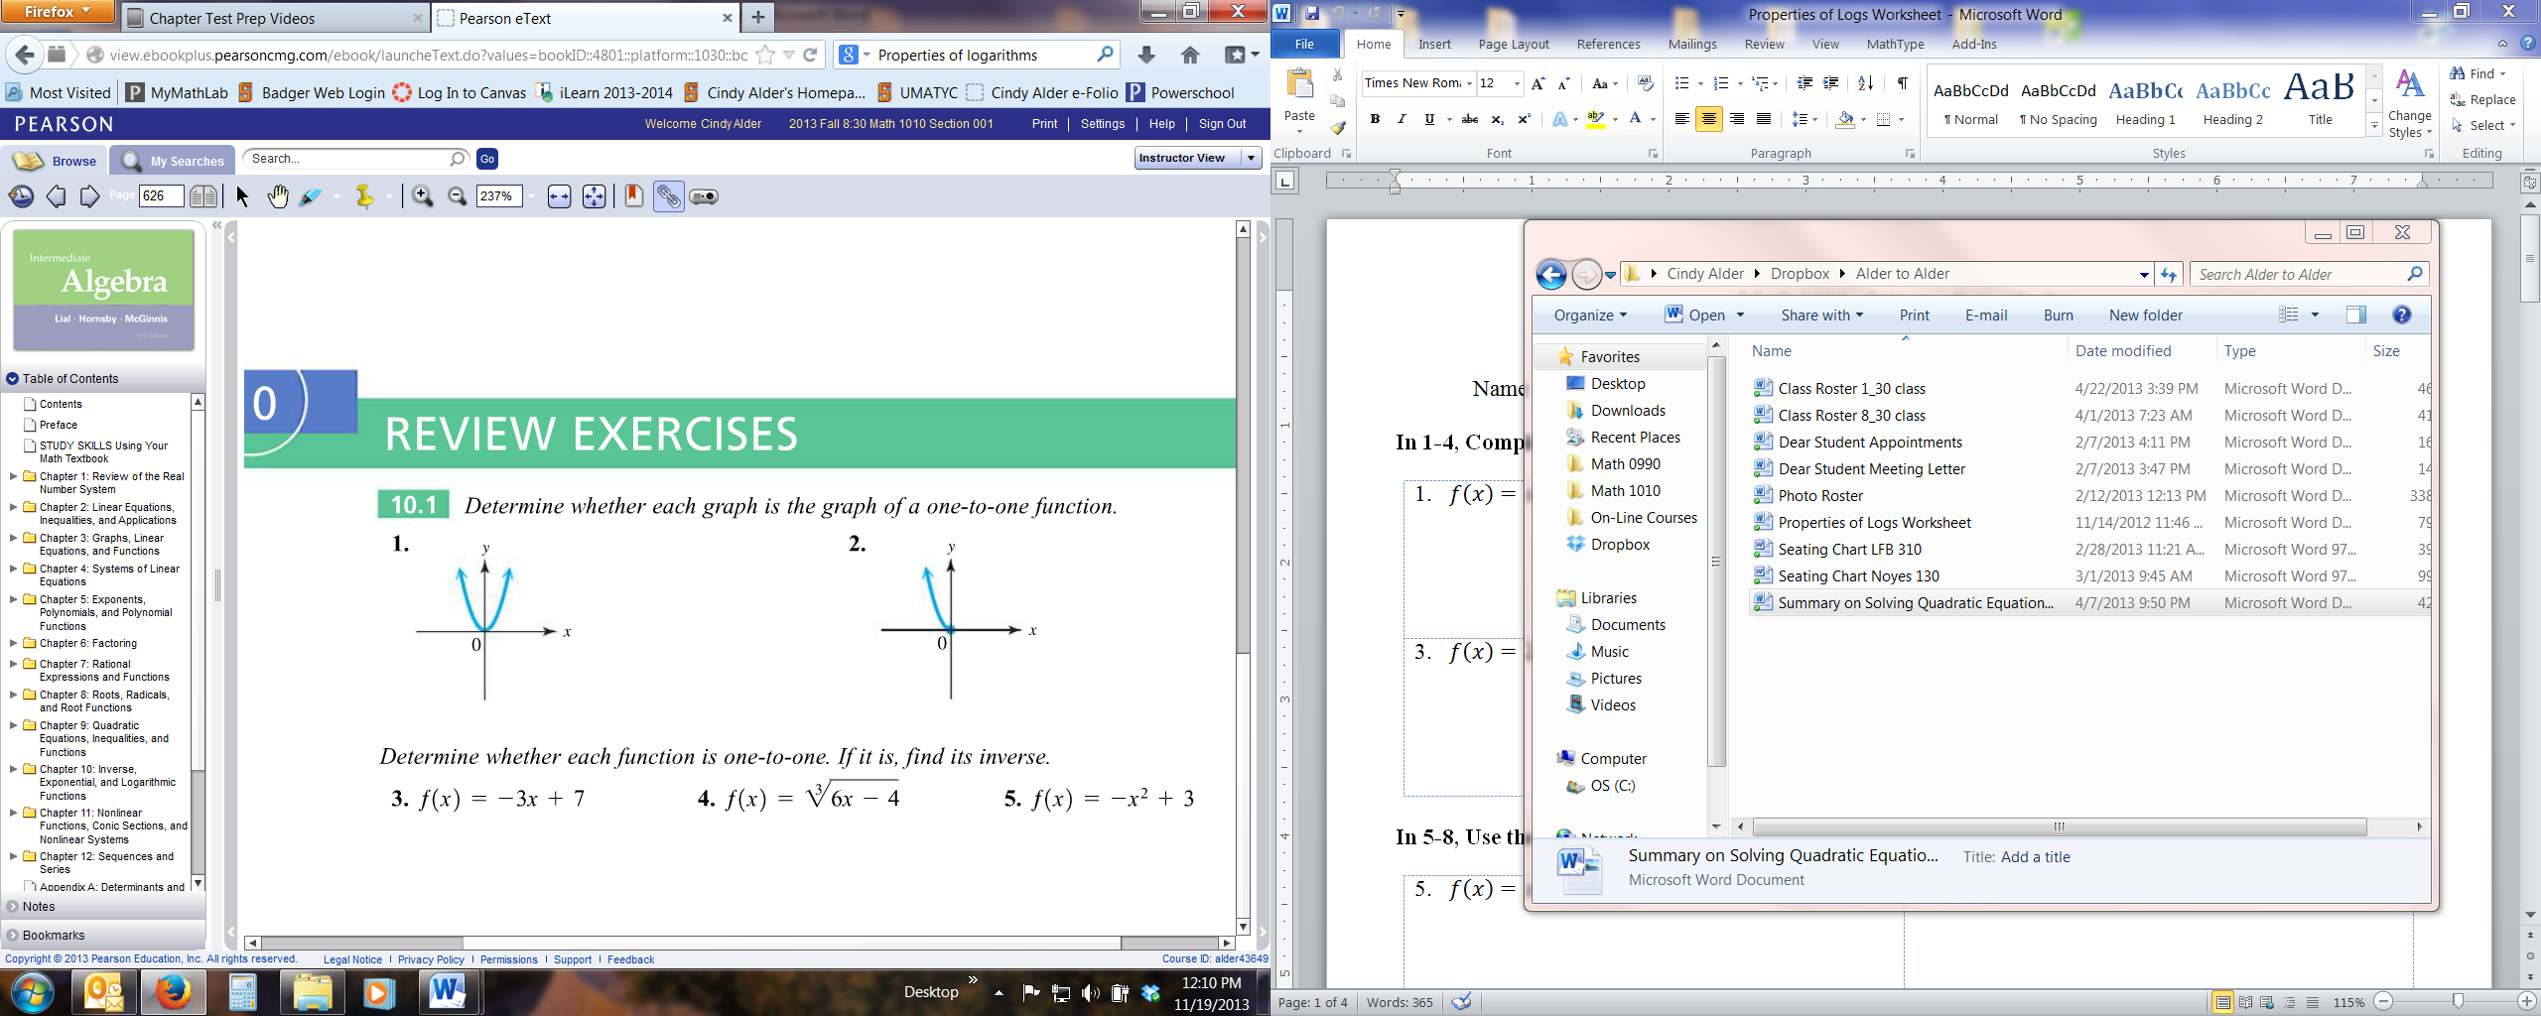  1) | 2)

In 3-5, Determine whether each function is one-to-one. If it is, find its inverse.
3) $f\left(x\right)=-3x+7$ | 4) $f\left(x\right)=\sqrt[3]{6x-4}$ | 5) $f\left(x\right)=-x^{2}+3$

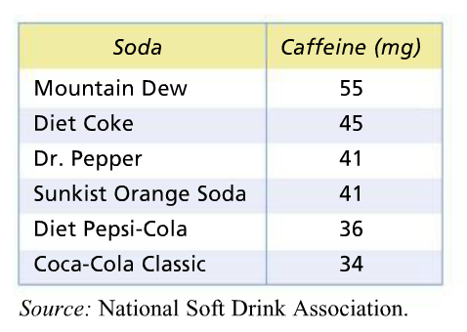
6) The table lists caffeine amounts in several popular 12-oz sodas. If the set of sodas is the domain and the set of caffeine amounts is the range of the function consisting of the six pairs listed, is it a one-to-one function? Why or why not?

In 7-8, Each function graphed is one-to-one. Graph its inverse on the same coordinate grid.

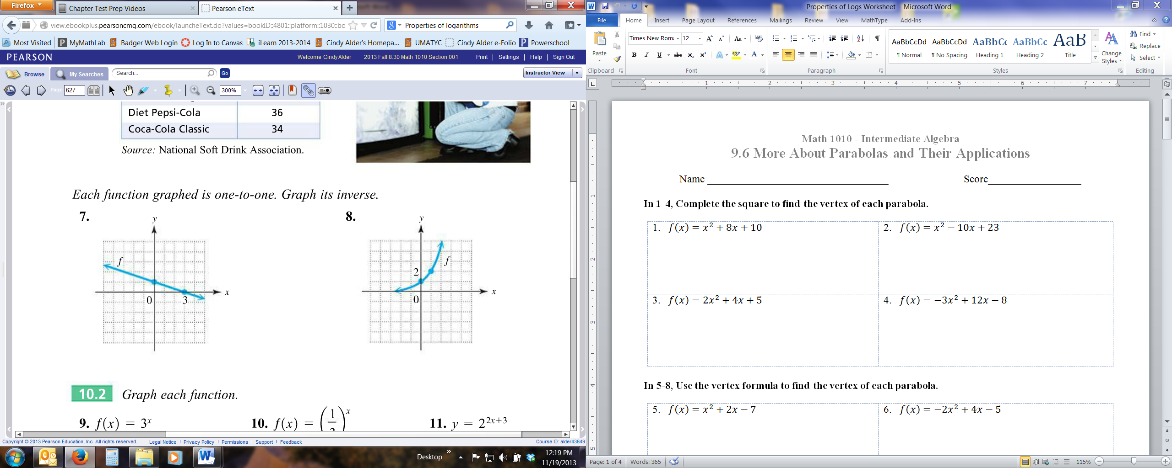  7) | 8)

In 9-11, Graph each function.

9) $f\left(x\right)=3^{x}$ | 10) $f\left(x\right)={\left(\frac{1}{3}\right)}^{x}$ | 11) $f\left(x\right)=2^{2x+3}$
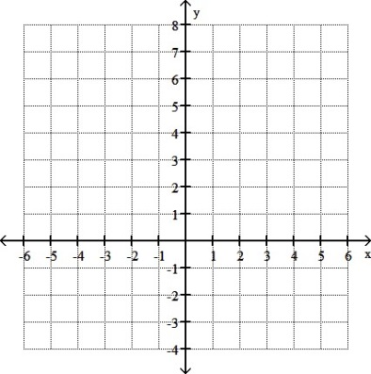

In 12-14, Solve each equation. (Hint: Rewrite with the same base.)
12) $5^{2x+1}=25$ | 13) $4^{3x}=8^{x+4}$ | 14) ${\left(\frac{1}{27}\right)}^{x-1}=9^{2x}$

15) Sulfur dioxide emissions in the United States, in millions of tons, from 1970 through 2007 can be approximated by the exponential function defined by
$$S\left(x\right)=33.07{\left(1.0241\right)}^{-x}$$
Where $x=0$ corresponds to 1970, $x=5$ to 1975, and so on. Use this function to approximate, to the nearest tenth, the amounts for each year. (Source: U.S. Environmental Protection Agency.)
(a) 1975 (b) 1995 (c) 2005

In 16-17, Graph each function. (Hint: write in exponential form.)

16) $g\left(x\right)=\log_{3}{x}$ | 17) $g\left(x\right)=\log_{\frac{1}{3}}{x}$
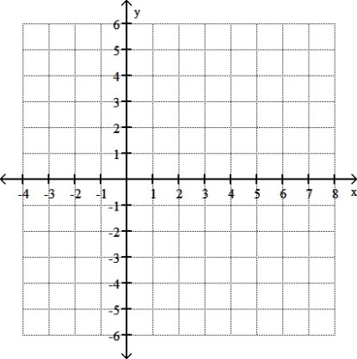

In 18-23, Solve each equation. (Hint: Rewrite in exponential form.)

18) $\log_{8}{64}=x$ | 19) $\log_{2}{\sqrt{8}}=x$ | 20) $\log_{x}\left(\frac{1}{49}\right)=-2$
21) $\log_{4}{x}=\frac{3}{2}$ | 22) $\log_{k}{4}=1$ | 23) $\log_{b}{b^{2}}=2$

24) In your own words, explain the meaning of $\log_{b}{a}$.

Properties of Logarithms
Name of Property | Property | Example
Special Properties | $\log_{b}{b}=1$ and $\log_{b}{1}=0$ | $\log_{8}{8}=1$ and $\log_{0.6}{1}=0$
Product Rule | $$\log_{b}{xy}=\log_{b}{x}+\log_{b}{y}$$ | $$\log_{5}{(6∙9)}=\log_{5}{6}+\log_{5}{9}$$
Quotient Rule | $$\log_{b}{\frac{x}{y}}=\log_{b}{x}-\log_{b}{y}$$ | $$\log_{4}{\frac{7}{3}}=\log_{4}{7}-\log_{4}{3}$$
Power Rule | $$\log_{b}{x^{r}}=r\log_{b}{x}$$ | $$\log_{5}{4^{2}}=2\log_{5}{4}$$
Special Properties | $b^{\log_{b}{x}}=x$ and $\log_{b}{b^{x}=x}$ | $4^{\log_{4}{10}}=10$ and $\log_{5}{5^{4}=4}$

In 25-26, Apply the properties of logarithms to express each logarithm as a sum or difference of logarithms. Assume that all variables represent positive real numbers.

25) $\log_{2}{3xy^{2}}$ | 26) $\log_{4}\left(\frac{\sqrt{x}∙w^{2}}{z}\right)$

In 27-28, Apply the properties of logarithms to write each expression as a single logarithm. Assume that all variables represent positive real numbers.

27) $\log_{b}{3}+\log_{b}{x}-2\log_{b}{y}$ | 28) $\log_{3}{(x+7)}-\log_{3}{(4x+6)}$

In 29-30, To four decimal places, the values of $\log_{10}{2}=0.3010$ and $\log_{10}{9}=0.9542$. Evaluate each logarithm by applying the appropriate rule or rules of logarithms. DO NOT USE A CALCULATOR.

29) $\log_{10}{18}$ | 30) $\log_{10}{36}$

In 31-32, Decide whether each statement is true or false.

31) $\log_{2}{(8+32)}=\log_{2}{8}+\log_{2}{32}$ | 32) $\log_{6}{60}-\log_{6}{10}=1$

